**Table Of Contents:**

Regular Language:

CFG:

TURING MACHINES:

Mealy and Moore Machines

PDA

MINIMIZATION

KLEEN’S THEOREM

OTHER

DFA:

Regular Expression:

Regular Expression Properties:

# Regular Language:

**Q2) Provide short answers to each of the following questions:** **[10 points = 5*2 points]**

a) Every subset of a regular language is regular.

b) Let L4 = L1L2L3. If L1 and L2 are regular and L3 is not regular, it is possible that L4 is regular.

c) Let L1 = L2 ∩ L3. Show values for L1, L2, and L3, such that L1 is context-free but neither L2 nor L3 is.

d) Let L1 = L2 ∩ L3. Show values for L1, L2, and L3, such that L1 is context-free but neither L2 nor L3 is.

e) Let L4 = L1L2L3. If L1 and L2 are regular and L3 is not regular, it is possible that L4 is regu

1. **There is a regular language L for which there is exactly one regular expression R with L(R) = L.**
2. **Union of regular language with context free language is not always a regular language.**
3. **L4 = L1∩L2∩L3, where L1 and L2 are regular and L3 is CFL. It is possible that L4 will be a regular language.**
4. **L2 = Complement of L1, where L1 is a CFL. It is possible that L2 will be a regular language.**
5. **The language L ={ aibj|i≥j} is regular language.**

**b) Let L 4 = L 1 U L 2 . If L 1 is regular and L 2 is not regular, then L 4 is regular. Discuss with an**

**example.**

**Solution:**

**a n b n and (a+b)* unite to form (a+b)* which is regular language**

# CFG:

a) Show a context-free grammar that generates L = {w ∈ {a, b}* : the first, middle, and last characters of w are identical}.

b) Convert the following grammar (over the alphabet {a, b, c, d}) to the Chomsky normal form.

**S → aSd | T**

**T → bTc | ɛ.**

c) Consider the following grammar *G*:

***S* → 1 *S* 1 | *T***

***T* → 1 *X* 1 | *X***

***X* → 0 *X* 0 | 1**

(i)What are the first four strings in the lexicographic enumeration of *L*(*G*)?

(ii)Show that *G* is ambiguous.

d) Let G be the context free grammar:

S →ASB | ɛ A →S | aAS | ɛ B →SbS | A | bb

(i) Find a grammar G1 which has no ɛ -rule and L(G1) = L(G) – { ɛ }. [5pts]

(ii) Find a grammar G2 which is equivalent to G1 and has no unit productions

e) Define components of CFG

Construct

1. **L1 ={ anbn|n≥1}**
2. **L2 ={ anbman|n≥1}**
3. **Find L1L2 and L1**∪**L2**

**Check whether the following grammar is ambiguous, take expression w=ibtibtaea**

**S → iCtS|iCtSeS C → b S → a**

**a) L4 = { 0 i 1 j 2 k | i,j&gt;=0,k&gt;=2}**

**b) L1 ={ 0 i 1 j 2 k |k &lt;=i }**

**L1**

**P2 P1**

**6 OF 3**

**c) L2 ={ 0 i 1 j 2 k |k &lt;=j }**

**d) Find L3 = L1L2**

**PAPER 2021^^**

True/False

* A production of the form non-terminal-> non-terminal is called a dead Production.
* Semi-word is a string having some terminals and one non-terminal at the right of string
* There exist exactly two different derivations in an ambiguous CFG for a word.
* 6) CFG may also represent a regular language.
* 10) The context free grammar *S->a|ab|SS|Sb* is ambiguous.
* 12) The concatenation of the two CFGs is not context free.
* 14) If L1 and L2 are context free, then the language L1 - L2 must be contextfree.
* 15) If L1 is context free and L2 is regular then the language L1 - L2 must be contextfree.

4) S → aXb|b, XaX → aX|bX|Λ The given CFG generates the language in English __________

1. Beginning and ending in different letters
2. Beginning and ending in same letter
3. Having even-even language
4. None of given

8) The language generated by that CFG is regular if _________

1. No terminal → semi word
2. No terminal → word
3. Both a and b

9) The terminals are designated by ________ letters, while the non-terminals are designated by ________ letters.

1. Capital, bold
2. Small, capital
3. Capital, small
4. Small, bold

10) The language generated by __________ is called Context Free Language (CFL).

1. FA
2. TG
3. CFG
4. TGT

13) The productions of the form nonterminal → one nonterminal, is called _________

1. Null production
2. Unit production
3. Null able production
4. None of given

15) Σ = {a,b} Productions

S→XaaX X→aX

X→bX

X→Λ

This grammar defines the language expressed by___________

1. (a+b)*aa(a+b)*
2. (a+b)*a(a+b)*a
3. (a+b)*aa(a+b)*aa
4. (a+b)*aba+b)*

**Question 1:**

**Construct a CFG which generates the following languages:**

a. L4 = { 0i1j2k| I >=2,j,k>=0}

b. L1 ={ 0i1j2k|j <=i }

c. L2 ={ 0i1j2k|j <=k }

d. Find L3 = L1∪L2

**Question 2:**

**Check the ambiguity in the following grammar with the help of at least 3 derivation trees.**

a E -> I

e. E -> E + E

f. E -> E * E

g. E -> (E)

h. I -> ε | 0 | 1 | 2| 3 | 4 | 5 | 6 | 7 | 8 | 9

**Question 3:**

**a)Write Down the CFG for following languages.**

• abbbb (a+ b)+aba

• Even Length Palindrome language over alphabet ∑= {a, b}

**b)Simplify the following CFG and Convert the resultant CFG into CNF**

S→ASA| BSB| A | B |a| b

A→ ASA|a|b|BSB|AS|SA|S

B→ BSB|a|b|BSB|AS|SA|S

C→ASA|AS|SA|S

**c)Convert the following CFG into PDA**

S → AB

A → aaA | ε, B → Bb| ε

**Question 4:**

a. **Write Down the CFG for following languages.**

·

ab (a+ b) *ab

·

Palindrome language over alphabet ∑=

{a,

b. **Simplify the following CFG and Convert the resultant CFG into CNF.**

S ->A|B

A-> 1CA|1DE|null

B->1CB|1DF

C ->1CC|1DG|0G

D->1CD|1DH

E->0A

F->0B

H->1

G->Null

**Question 5:**

a. **Convert the following CFG into PDA**

S -> ABC|AB|AC|C

B -> 0|1

C ->AC|B

D ->0|1

**Question 6:**

The specifications of your target language (MagicL) is as follows:

The alphabet **∑** set contains five symbols, which will be defined as follows:

**(1)** first letter of your first name

**(2)** the last letter of your first name

**(3)** the first letter of your last name

**(4)** the last letter of your last name

**(5)** the character $.

For example, if name is “*Ahmed Zubair*” so, in this case, the alphabet for MagicL is **∑={a, d, z, r, $}**. Clearly the alphabet for your language is likely to be different.

**Note:** If your name is like “nina nolan” and does not give **4** distinct letters, then choose the alternative letter(s) in consecutive order from your name, so if you were named as in the example you could use **∑= {n, a, o, l, $}** as your alphabet.

Strings of your language must satisfy the following constraints:

The first is that there is exactly one $ in any correct string, and this is always the last symbol in the string. The string before the $, which must be non-empty, we call a **correct expression**, defined as follows:

**-** A sequence of one or more of the second symbol (2) and/or third symbol (3) in any order, bracketed by the first symbol (1) and fourth symbol (4), OR

**-** A correct expression bracketed by the first (1) and last letter (4), i.e. for every letter (1) in the string, there must be a unique corresponding matching last letter (4). OR **-** A sequence/repetition of correct expressions.

**Examples of Correct Strings:**

So for my language MagicL, examples of correct strings in the language are (separated by semi colons): **adzzr$ ; aaadzzrrr$; aazzdzddzdddzrr$; aaadddrdzzrr$; adraddr$; aaazraddzrrr$**.

**Examples of Incorrect Strings:**

Strings of the alphabet which are NOT in the language include: aadrrar$ (no “d” or “z" inside the last “ar”); aaadrrz$ (missing “r” at the end); aaadrrrrzzddr$ (the fourth “r” and last "r" do not have a corresponding starting “a”).

**You are required to:**

**(i)** Create your alphabet set using your full name.

**(ii)** create a context-free grammar which generates exactly the language described above using your name;

**(iii)** use your grammar to generate a parse tree of a chosen string in your language which uses all 5 letters of the alphabet;

**Note:** Your grammar should be small, consisting of not greater than 6 production rules.

**True/False**

| 6) CFG may also represent a regular language. | T/F |
| --- | --- |
| 10) The context free grammar S->a|ab|SS|Sb is ambiguous. | T/F |
| 11) The class of non-regular languages is closed under complementation. | T/F |
| 12) The concatenation of the two CFGs is not context free. | T/F |
| 13) The class of the non-context free languages is closed under complementation. | T/F |
| 14) If L1 and L2 are context free, then the language L1 - L2 must be context free. | T/F |
| 15) If L1 is context free and L2 is regular then the language L1 - L2 must be context free. | T/F |

**Question 7:**

**Construct a CFG which generates the following languages:**

a.

L1 ={ anbn|n≥1}

b.

L2 ={ anbman|n≥1}

Find L1L2 and L1∪L2

## MCQs

4) S → aXb|b, XaX → aX|bX|Λ

The given CFG generates the language in English __________

A. Beginning and ending in different letters

B. Beginning and ending in same letter

C. Having even-even language

D. None of given

10) The language generated by __________ is called Context Free Language (CFL).

A. FA

B. TG

C. CFG

D. TGT

13) The productions of the form nonterminal → one nonterminal, is called _________

A. Null production

B. Unit production

C. Null able production

D. None of given

Question 8:

**Construct a CFG which generates the following languages:**

a. L4 = { 0i1j2k| i,j>=0,k>=2}

b. L1 ={ 0i1j2k|k <=i }

c. L2 ={ 0i1j2k|k <=j }

d. Find L3 = L1∪L2

e) Construct left most derivation tree for string 001122 for language L1 and L2.

f)

g) Check whether the grammar L3 is ambiguous, take expression W=001122.

**Question 9:**

Write down the CFG/RG for the languages L1, L2 and L3.

Draw the derivation trees for word abbc from CFG/RG of L1, abab from CFG/RG of L2 and aabbbbbbbbbb from CFG/RG of L3.

(i) L1 = {a^nb^(n+m)c^m: n, m ≥ 0}

L2 = {(ab)^2n: n ≥ 0}

(ii) L3 = {a^nb^(2n+6): n ≥ 0}

**Question 10:**

Write CFG of the following languages:

a. *L*1 = {anbm,(n+m) is divisible by 2}

b. *L*2 = {*anbn*−3 : *n* ≥ 3}

c. *L3* = {ambncp | m>n>p }

**Question 11:**

Construct a CFG which generates the following languages:

1. L1 ={ anbn|n≥1}
2. L2 ={ anbman|n≥1}
3. Find L1L2 and L1∪L2

# CNFs

**Question 1:**

**Consider the following CFG for non-empty language:**

S→ASA│BSB│AA│BB│A│B

S→ASA│BSB│AA│BB│a│b

Q→CA│DB│AA│BB│a│b

N → ab |AS | ε

M → bS| Cab| ε

a. Simplify showing each steps clearly.

b. Convert the above CFG into CNF.

**Question 2:**

**Consider the following CFG for non empty language:**

S1 → S

S → aSb|BB|BCD |ab|BC

A → DD | B| BCB | D | ε

B → AB |C | ε

C → Cc|c

a.

Simplify showing each steps clearly.

b.

Convert the above CFG into CNF.

**Question 3:**

a) Show a context-free grammar that generates L = {w ∈ {a, b}* : the first, middle, and last characters of w are identical}.

b) Convert the following grammar (over the alphabet {a, b, c, d}) to the Chomsky normal form.

**S → aSd | T**

**T → bTc | ɛ.**

c) Consider the following grammar *G*:

***S* → 1 *S* 1 | *T***

***T* → 1 *X* 1 | *X***

***X* → 0 *X* 0 | 1**

(i)What are the first four strings in the lexicographic enumeration of *L*(*G*)?

(ii)Show that *G* is ambiguous.

d) Let G be the context free grammar:

S →ASB | ɛ A →S | aAS | ɛ B →SbS | A | bb

(i) Find a grammar G1 which has no ɛ -rule and L(G1) = L(G) – { ɛ }. [5pts]

(ii) Find a grammar G2 which is equivalent to G1 and has no unit productions

e) Define components of CFG

**Question 4:**

**Consider the following CFG for non-empty language:**

S → a|aAb|abSb

A → bS| aAAb| Cab | ε

B → ab |AS | ε

**D →** bS| Cab| ε

a. **Simplify showing each steps clearly.**

S → a|aAb|abSb

A → bS| aAAb| Cab | ε

B → ab |AS | ε

D → bS| Cab| ε

**B, C and D are useless productions**

S → a|aAb|abSb

A → bS| aAAb| ε

**Remove A🡪 null**

S → a|aAb|abSb | ab

A → bS| aAAb| aAb | ab

**Rest Can be converted into CNF**

b)Convert the above CFG into CNF.

**Questio n 5:**

Check whether the following grammar is ambiguous, take expression w=ibtibtaea

S → iCtS|iCtSeS C → b S → a

# Ambiguity

**Are ambiguous grammar context free?**

a) Yes

b) No

**Check whether the following grammar is ambiguous, take expression w=ibtibtaea**

**S → iCtS|iCtSeS C → b S → a**

# 

# Simplification

Which among the following productions are Useless productions?

a) S->A

b) A->aA

c) A->e

d) B->bA

# TURING MACHINES:

a) Design Turing machine for language:

1. L = {0n1m2n | 2m<=n<=4m}
2. L = { abc (a + b)*cba}
3. Draw Chomsky Hierarchy and discuss.

b) Give Pseudocode and its corresponding TM for the following functions:

(15+10) Points

2. A = {0n | n is a power of 3}

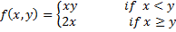

a) Design Turing machine for language:

1. L = {ab, ba, aa, bb)}
2. L = { abc (a + b)*cba}
3. Elaborate the concept of recursively enumerable languages by drawing Chomsky’s hierarchy.

b) State the various states of the Turing machine and explain all the states by giving examples.

1. Design the Turing Machine for abb(a+b) *010. Draw the Turing Tape and Show that whether the word 010 would be accepted by the Turing Machine or not.
2. Draw Chomsky’s Hierarchy and highlight the type languages for which Turing machine can be formed. Also Elaborate the concept of the Type 0, Type 1, Type 2 and Type 3 grammars.
3. Design a Turing machine for (a+b) * and discuss whether the languages {aabb, bba} and {aaa,bbb} would be accepted by this Turing machine or not.
4. Discuss the concept of blank symbol in Turing machine, also discuss why Turing machine has infinite tape?
5. Discuss whether Turing machines are deterministic or not? With proper example.
6. Design the Turing Machine for 011(0+1) *010. Draw the Turing Tape and Show the steps for word 010.
7. Draw Chomsky’s Hierarchy and highlight the type languages for which Turing machine can be formed.
8. Design a Turing machine for (0+1) * and discuss whether the languages (0+1) + and (001+111) would be accepted by this Turing machine or not.
9. Elucidate the difference between ‘accept and halt’ and ‘halt and reject’ in Turing machine.
10. Is it considerable to have a self-loop on final state of the Turing machine? Justify?
11. Design the Turing Machine for 011(0+1) *010. Draw the Turing Tape and Show the steps for word 010.
12. Draw Chomsky’s Hierarchy and highlight the type languages for which Turing machine can be formed.
13. Design a Turing machine for (0+1) * and discuss whether the languages (0+1) + and (001+111) would be accepted by this Turing machine or not.
14. Elucidate the difference between ‘accept and halt’ and ‘halt and reject’ in Turing machine.
15. Is it considerable to have a self-loop on final state of the Turing machine? Justify?

i. L1 ={anbmcn+m|m≥(mod 10 of your four digit roll number), n≥0}.

ii. Your target TM reads your name and encrypts it with the last digit of your roll no. Encryption function is as follows:

Each letter in the plaintext is 'shifted' a n number of places down the alphabet, where n is the last digit of your roll no. For example, if n=1, then with a shift of 1, A would be replaced by B, B would become C, and so on. If the plaintext letter is Z then with a shift of 1, Z would be replaced by A. This is a kind of cyclic shift function.

Universal turing machine

i. Discuss UTM with respect to its motivation, application, capabilities (expressing power) and limitation. Give only one point on each of the above aspects. Each point must not exceeds the two lines description.

ii. What is the encoded representation (string) passed to The UTM for this TM.

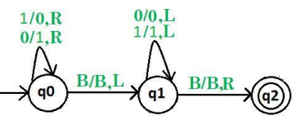

a) Design Turing machine for language:

1. L = {0n1m| 2n<=m<=3m}
2. L = { abb (a + b)*}
3. Draw Chomsky Hierarchy and discuss.

b) Give Pseudocode and its corresponding TM for the following functions:

(15+10) Points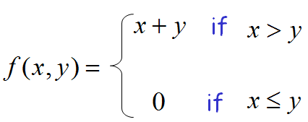

1. A = {0n | n is a power of 2}

a): Prove that the following function is computable.

f(n)=n+2.

We know that if any function is computable, then there exists a Turing Machine for it. So, it will be sufficient to construct a TM to prove any function is computable.

TM behaves as follows:

q0IIIB ├* IIIq0B ├IIIIq1B ├* IIIIIBhB

b) Construct a Turing Machine accepting a language of palindrome over {a,b}* with each string of even length.

Create Turing Machines for the following languages and function:

L2 ={a3nbnc2n|n≥2}.

$f\left(x,y\right)=\left\{{}_{"zero"x≥y}^{x+yx<y}\right\}$

Give an example of infinite loop resulting in Non-Halting TM.

Give formal definitions of a two-tape Turing machine for the language {w | wR = w is any string of 0’s and 1’s}.[Hint: give some example]

1. Draw the Chomsky hierarchy of languages with the Venn diagram. Also label recursive, recursively enumerable, non recursively enumerable, decidable problems and undecidable problems in the drawn Venn diagram.
2. Define the following terms:
3. Recursive TM,
4. Recursively Enumerable TM,
5. Undecidable Problems.
6. Define Universal Turing Machine. Give an example of UTM

Select and design the best machine for the following language:

L = { (anbncmdm| n=2,m=2) ∪ (anbmcmdn| n=2, m=1}

Justify your selection regarding its working, time cost and storage cost.

a) Design Turing machine for language:

1. L = {0 n 1 m | 2n&lt;=m&lt;=3m}

2. L = { abb (a + b)*}

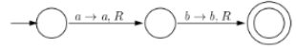

11. A Turing machine operates over:

a) finite memory tape

b) infinite memory tape

c) depends on the algorithm

12. Which of the functions are not performed by the Turing machine after reading a symbol?

a) writes the symbol

b) moves the tape one cell left/right

c) proceeds with next instruction or halts

d) none of the mentioned

13.Which of the following a Turing machine does not consist of?

a) input tape

b) head

c) state register

d) none of the mentioned

14. Which of the following options resemble with the given Turing Machine?

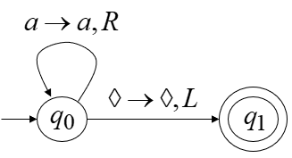

1. a*
2. a+
3. λ
4. none

15. Turing Machine accepts following languages

a) Recursively Enumerable

b) Regular Languages

c) Context Free Languages

d) Context Sensitive Languages

c) All of these

d) None of these

# Mealy and Moore Machines

The circuit of a simple 3-bit Up/Down counter gives a maximum count of zero (000) to seven (111) and back

to zero again. The 3-Bit counter advances upward in sequence (0,1,2,3,4,5,6,7) or downwards in reverse

sequence (7,6,5,4,3,2,1,0). Design a mealy machine for the 3-bit Up/Down counter, which produce the

upward and downward sequence in between 000 and 111. The input and output alphbet of this machine

are ∑={0, 1} and ∆ ={0,1}. Some of the random input/output transitions on some states are as follows:

[Note: Mealy & Moore machines are capable to

produce strings by reading 1 input symbol e.g.

following intermediate transition represents that, by

reading 1, 010 will be produced as output.]



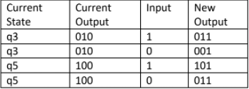

Convert the given Mealy machine into equivalent

More Machine:

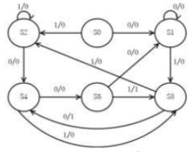

Convert the following mealy machine in equivalent Moore machine.

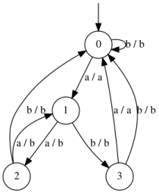

Convert the Machine mentioned in Fig.3 to its equivalent machine.

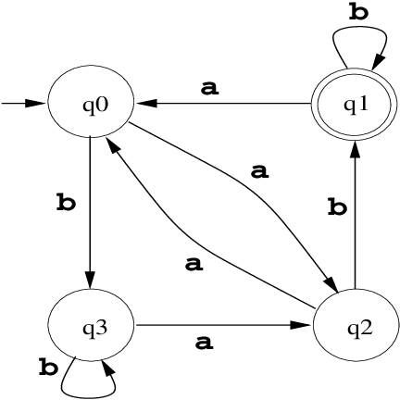 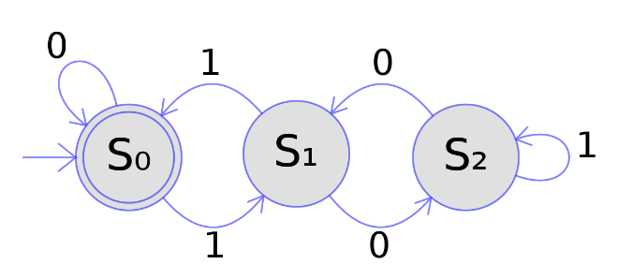

**Fig.1**  **Fig.2**

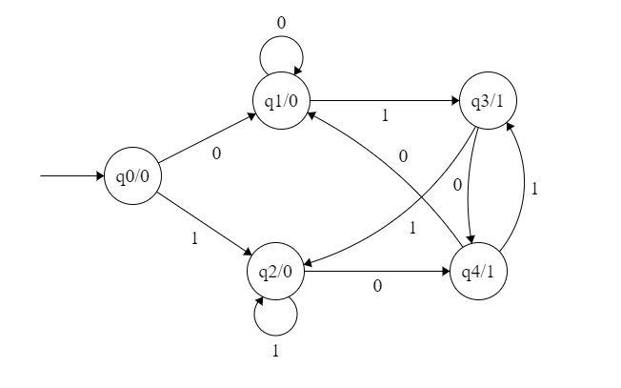

Convert the Machine mentioned in Fig.3 to its equivalent machine.

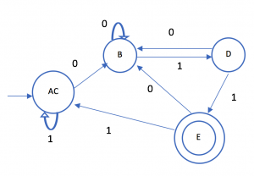 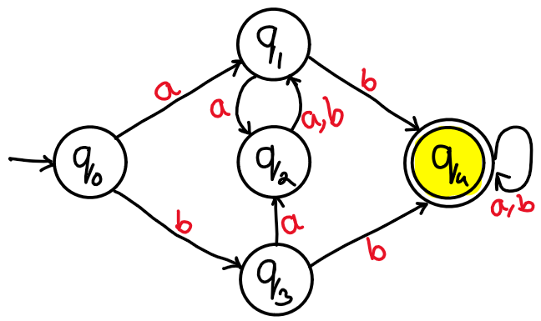

**Fig.1**  **Fig.2**

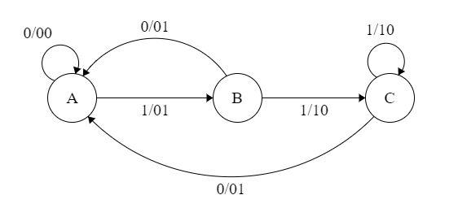

Convert the Machine mentioned in Fig.3 to its equivalent machine.

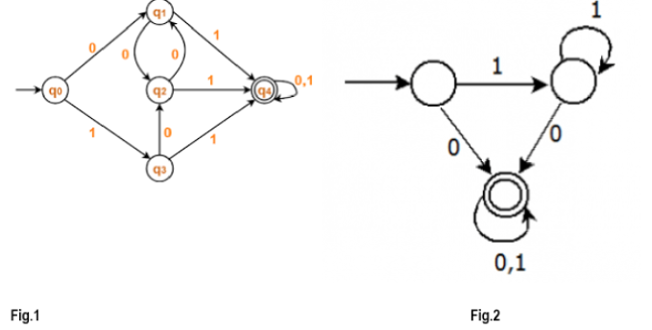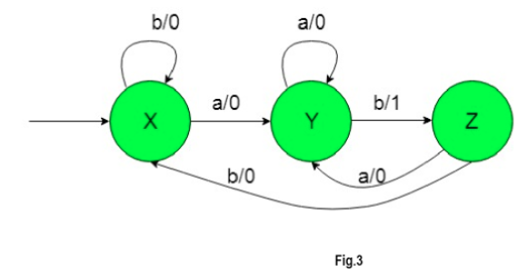

# PDA

2. A string is accepted by a PDA when

a) Stack is not empty

b) Acceptance state

c) All of the mentioned

d) None of the mentioned

4. Which of the following option resembles the given PDA? (# is stack symbol).

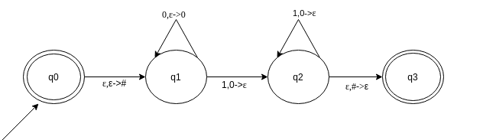

Find the option which resembles the given PDA

**a) {0n1n|n>=0}**

**b) {0n12n|n>=0}**

**c) {02n1n|n>=0}**

d) None of the mentioned

Design a PDA for even-even language.

Show the stack operations for the word abababab on the PDA you have designed.

Design a PDA for following language

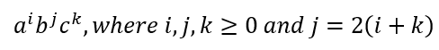

Design a PDA for following language

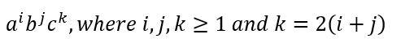

a. Design a PDA for even language and odd language.

b. Show the stack operations for the words of your choice on each the above PDAs.

c. Design a PDA for following language having equal number of 0’s and 1’s. d. Design a PDA for following language

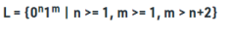

1. Convert the following CFG into PDA:

S → AB

A → aaA | ε, B → Bb| ε

P.D.A. (10+10) Points

a) Identify language of given CFG, construct a P.D.A. and trace the input string ------ using stack :

S→ 0S11| 0S111 |^

Trace the input string "001111" using stack. Is the string accepted by the grammar?

b) Construct a PDA for language  **L ={ anbmckdl|n+m = (2k+2l)/2 ≥0}**. Trace the input string, which belong to language (length of string should be at least 6) using stack.

1. Identify language of given CFG, construct a P.D.A. and trace the input string ------ using stack :

S🡪 0S111| 0S1111 |^

Trace the input string "0011111" using stack. Is the string accepted by the grammar?

1. Construct a PDA for language **L ={ anbmckdl|n+m = (k+l)/2 ≥0}**. Trace the input string, which belong to language (length of string should be at least 6) using stack.

Construct a pushdown automata for accepting a postfix notation. Also give one example on your own choice and show all stack updates in accepting or rejecting the input notation. Alphabet ∑ of the language is {1,2,3, +, -}.

a) Identify language of given CFG, construct a P.D.A. and trace the input string ------

using stack :

S 0S11| 0S111 |^

Trace the input string &quot;0011111&quot; using stack. Is the string accepted by the

grammar?

b) Construct a PDA for language L ={ a n b m c k d l |n+m = 2(k+l) ≥0}. Trace the

input string, which belong to language (length of string should be at least 6) using

stack.

7) PDA is stronger than FA. T/F

8) There always exist an FA for each PDA. T/F

The PDA is called non-deterministic PDA when

there are more than one outgoing edges from………

state

A. START or READ

B. POP or REJECT

C. READ or POP

D. PUSH or POP

Identify the TRUE statement:

A. A PDA is non-deterministic, if there are more

than one READ states in PDA

B. A PDA is never non-deterministic

C. Like TG, A PDA can also be non-deterministic

D. A PDA is non-deterministic, if there are more

than one REJECT states in PDA

a) Process the string aaabbb and fill the table with all possible values of State, STACK and Tape using following NPDA:

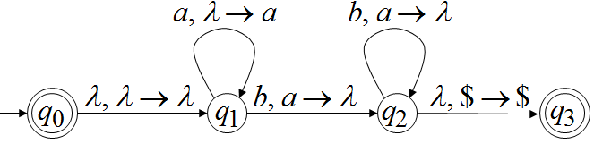

| **STATE** | **STACK** | **TAPE** |
| --- | --- | --- |
| qo | $ | aaabbb |
|  |  |  |
|  |  |  |
|  |  |  |

Note: Highlights the current tape symbol with underline

b) Suppose the PDA



has the following transition function:

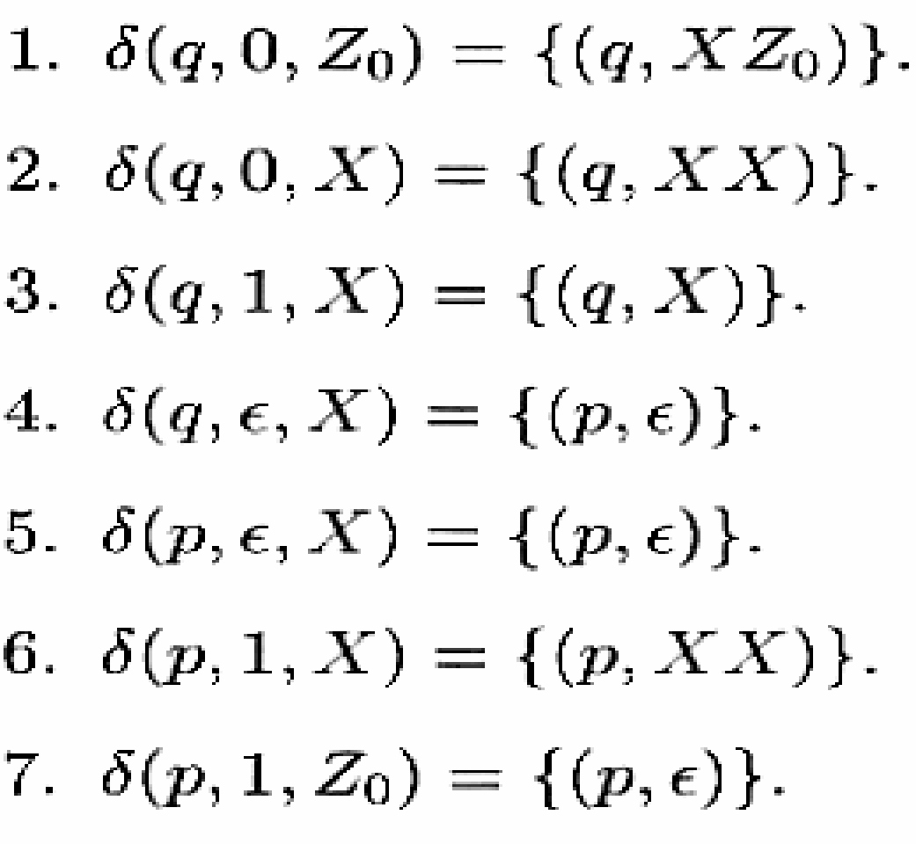

Starting from the initial ID (q, w, Z0), show all the reachable ID's when the input w is:

i) 01

ii) 0011

c): Convert the following expression grammar into a PDA:

I → a | b | Ia | Ib | I0 | I1

E → I | E * E | E + E | (E)

d) Construct PDA of the given language:

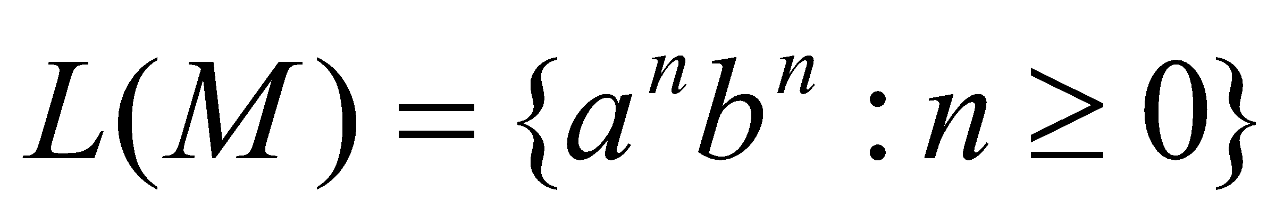

e) Write down the capabilties of PDA which cannot be achieved by CFG.

a) Construct an equivalent P.D.A. from the following CFG:

S aTb| b

T Ta | ɛ

b) Trace the input sring &quot;aaab&quot; using stack.

c) Construct a P.D.A. accepting for the language L ={ a 4 b n c n |n≥0}

1. Identify language of given CFG, construct a P.D.A. and trace the input string ------ using stack :

S🡪 0S11| 0S111 |^

Trace the input string "0011111" using stack. Is the string accepted by the grammar?

1. Construct a PDA for language **L ={ anbmckdl|n+m = 2(k+l) ≥0}**. Trace the input string, which belong to language (length of string should be at least 6) using stack.

I considered the possible variations also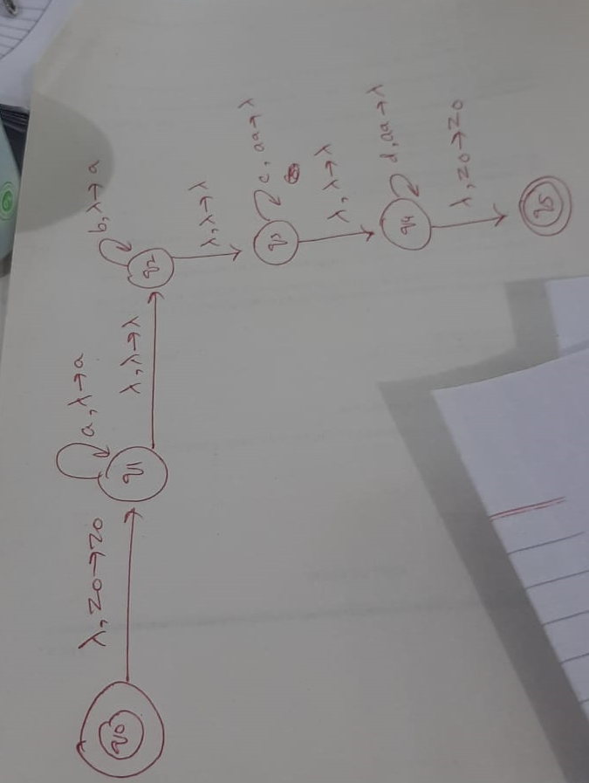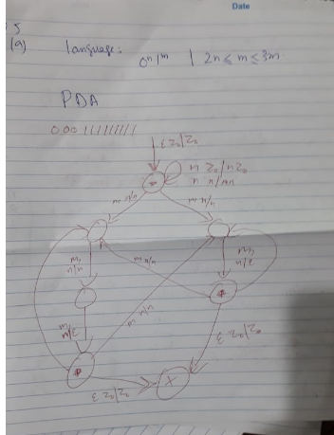

# MINIMIZATION

**16. Minimum number of states required to design a DFA which accepts strings ending with 10 having alphabet {0,1}.**

a) 4

b) 3

c) 2

16. Number of states require to accept string ends with 10 having alphabet {0,1}.

a) 3

b) 2

c) 1

d) can’t be represented.

**c) Minimize the following DFA using the method of your own choice.** 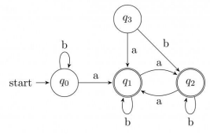

In the given DFA mark the final states by using all non zero digits of your four digit roll number.(For Roll # K18-1019, accepting states will be 1 and 9). Now minimize your after deciding the accepting state(s) in the given DFA. Show Proper working and draw the minimized DFA.

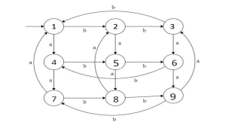

**Find the minimal DFA of the following:**

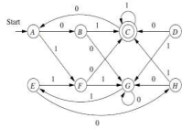

Solution:

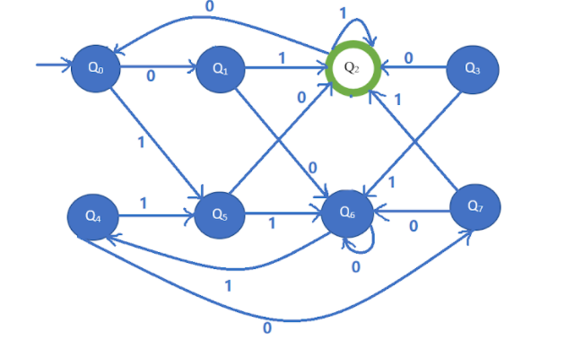

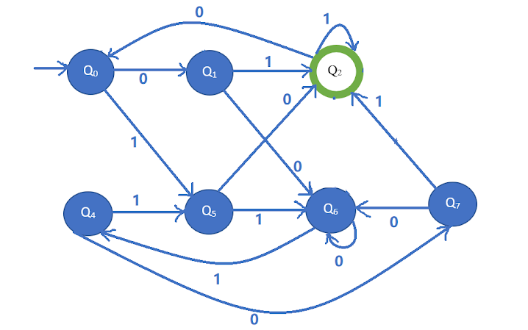

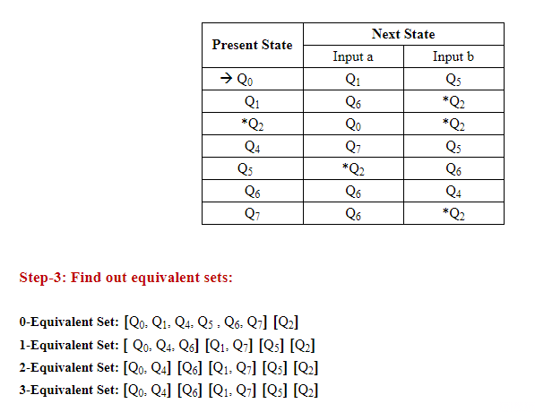

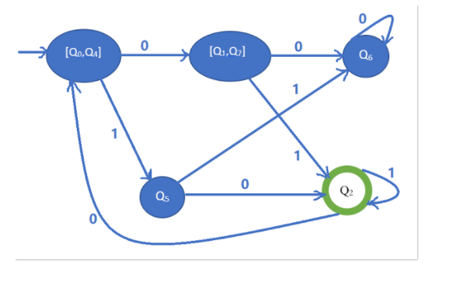

Question 4: Minimize the following DFA using either partitioning method or TF Algorithm:

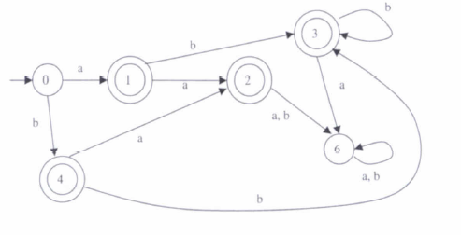

Question 3: Minimize the following DFA using partioning method:

Question # 1 (5 Points) Minimize the DFA mentioned in Fig. 1 using any method of your choice.

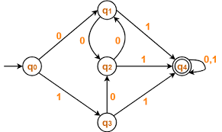

Solution:

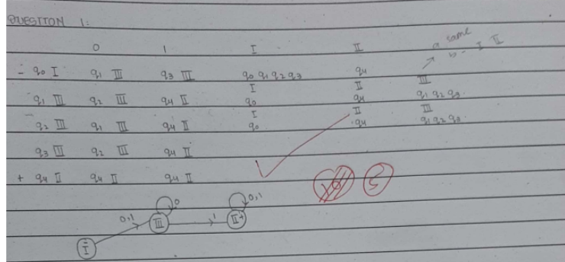

Question # 1 (5 Points) Minimize the DFA mentioned in Fig. 1 using any method of your choice.



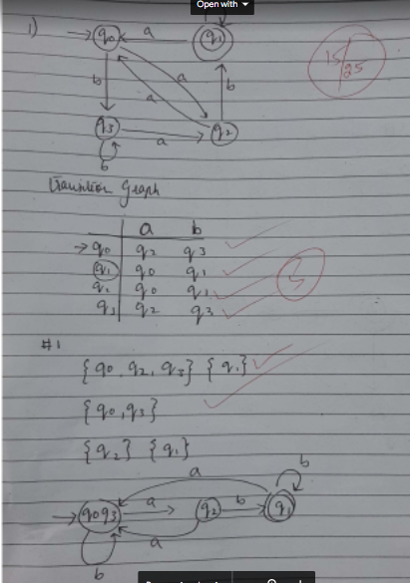

Question # 1 (5 Points) Minimize the DFA mentioned in Fig. 1 using any method of your choice.



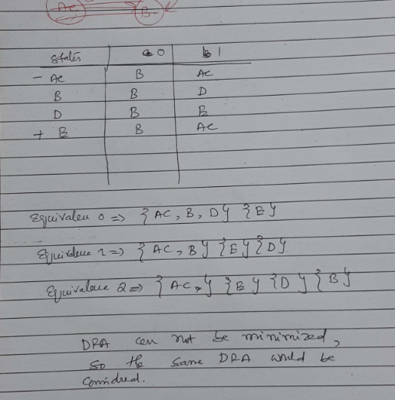

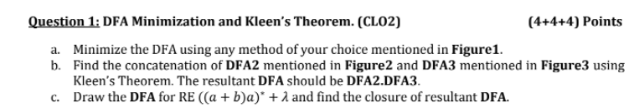

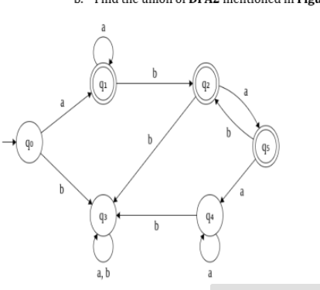

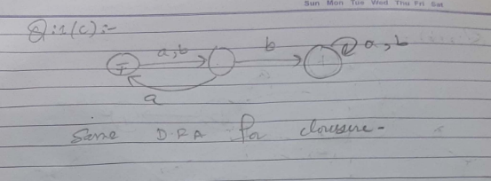

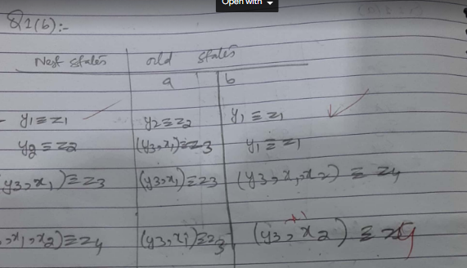

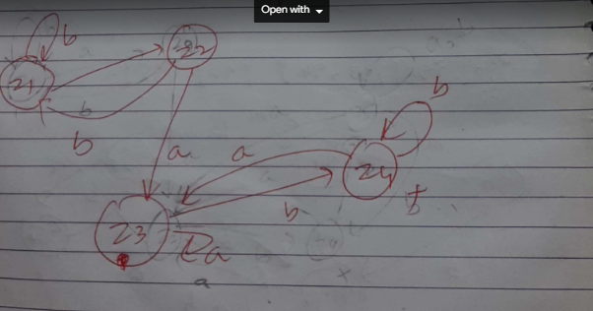

# KLEEN’S THEOREM

1. **Perform the union of the following DFAs.**
2. **Perform Concatenation of following DFAs.**
3. **Identify the languages of the following DFAs.**
4. **Write down the regular Expressions of the following DFAs**

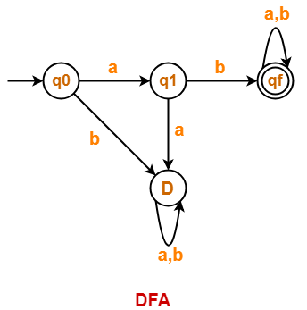 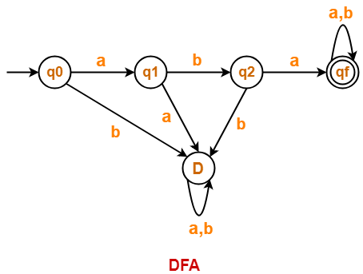

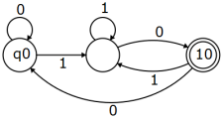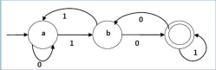

**Find out the union and intersection using Kleen’s Theorem of the following FAs.**

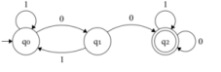 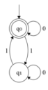

**Solution**

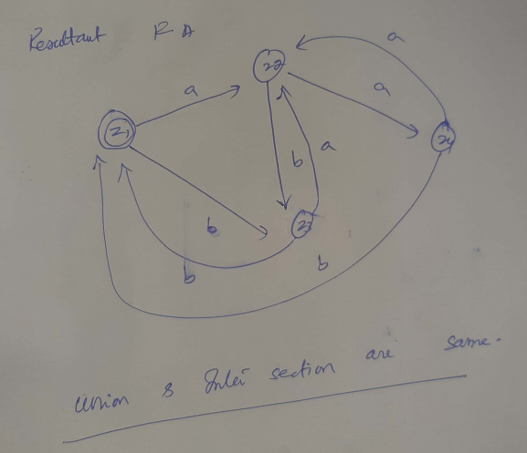

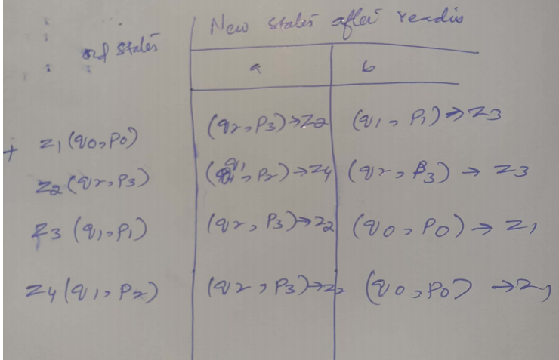

**Find closure of the given below FA:**

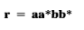 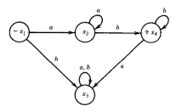

**Question 5: (GTG and State Elimination) 10 Points**

**Find the regular expression of the DFA given in figure 2, using state**

**elimination method.**

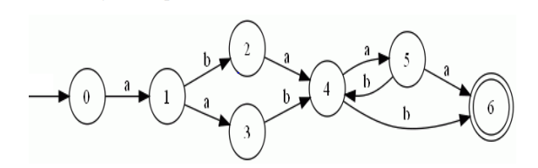

**a) Find out the union and intersection of the following FAs.**

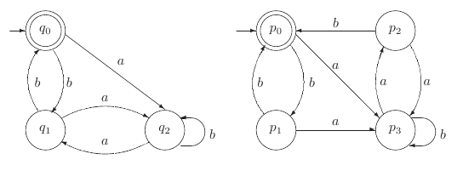

Question3: Derive the RE for the language accepted the following nfa. For full credit show all the steps clearly.

[Hint: Use approach discussed in Kleen’;s Theorem]

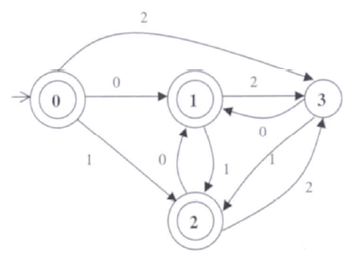

1. **Construct the FA for a language upon ∑ ={a,b,c} which accepts all strings not ending with "abc".**
2. **Construct the DFA A for strings accepting all 0's and odd 1's. State the R.E.**
3. **Construct the DFA B for strings accepting all 1's ending with odd 0's.State the R.E.**
4. **Concatenate the DFA's A and B to find DFA AB.**
5. **Take the union of A and B to find a DFA for A∪B.**

**5) Regular languages are closed under Union, Concatenation and Kleene star. T/F**

**Question # 2 (5 Points)** Perform closure on DFA mentioned in **Fig. 2** using kleen’s theorem

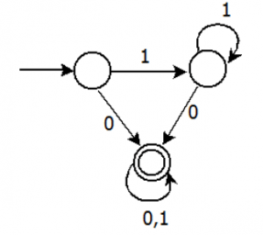

Solution

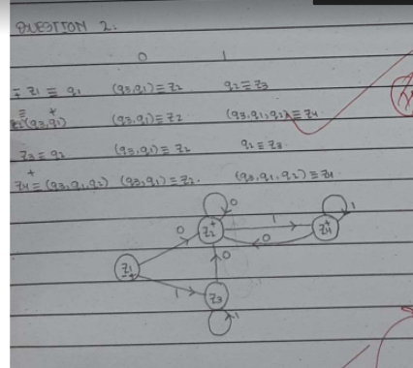

**Question # 2 (5 Points)** Perform Closure on DFAs mentioned in **Fig. 2** using kleen’s theorem.



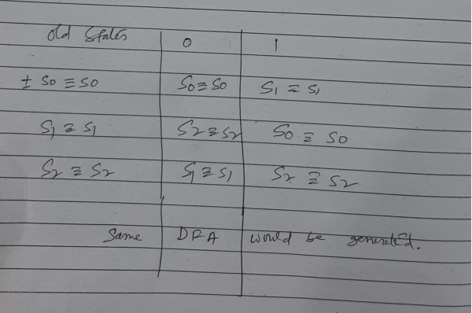

**Question # 2 (5 Points)** Perform union on DFAs mentioned in **Fig. 1** and **Fig. 2** using kleen’s theorem.



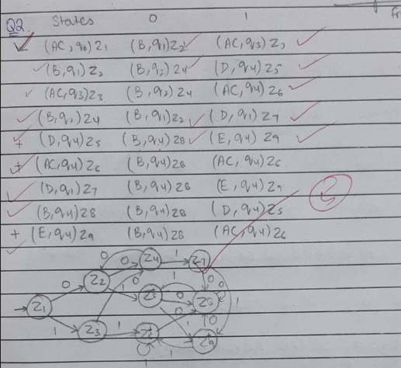

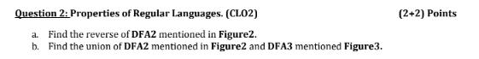

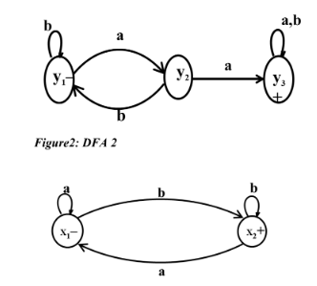

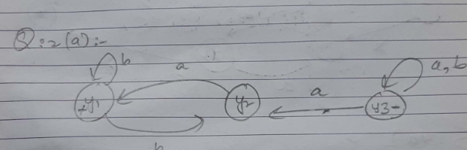

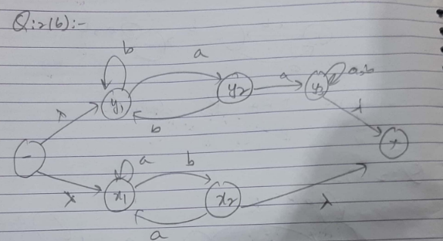

# OTHER

6. Which of the following statement is false?

a) Context free language is the subset of context sensitive language

b) Regular language is the subset of context sensitive language

c) Recursively enumerable language is the super set of regular language

d) Context sensitive language is a subset of context free language

18. The basic limitation of finite automata is that

a) It can’t remember arbitrary large amount of information.

b) It sometimes recognizes grammar that are not regular.

c) It sometimes fails to recognize regular grammar.

d) All of the mentioned

20. If L is a regular language, complement and reverse of language both will be:

a) Accepted by NFA

b) Rejected by NFA

c) One of them will be accepted

1. A Finite automaton employs ________ data structure.

a) Queue

b) Linked List

c) Hash Table

d) none

2. A string is accepted by a FA when

a) Stack is not empty

b) Acceptance state

c) All of the mentioned

d) None of the mentioned

7. For S->0S1|e for ∑={0,1}*, which of the following are correct for the language

produced?

a) Non regular language

b) 0n1n | n>=0

c) 0n1n | n>=1

d) None of the mentioned

b) Let L 4 = L 1 U L 2 . If L 1 is regular and L 2 is not regular, then L 4 is regular. Discuss with an

example.

Solution:

a n b n and (a+b)* unite to form (a+b)* which is regular language

Question 1a: Provide 2-3 line replies to all of the following short questions. Answer that exceeds 3 lines will not be

considered. [10 points]

A) If a language can be expressed in the form of FA than why it is needed to use NFA ?

B) Write down differences between Palindrome and Reverse function? Elaborate with example.

C) what are the conditions of NFA-Null to NFA conversion to recognize the language L.

D) Intersection of two non-regular languages is always non-regular. Is it true or false? Give your statement with proof.

E) L k = {a p : p is any prime number less than a very large given integer k}, L k is a regular language. Is it true or false? Give your

statement with proof.

# DFA:

**b) Convert the following NFA to equivalent DFA.**

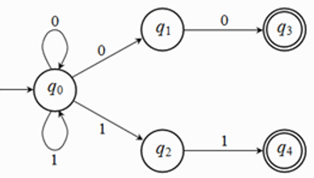

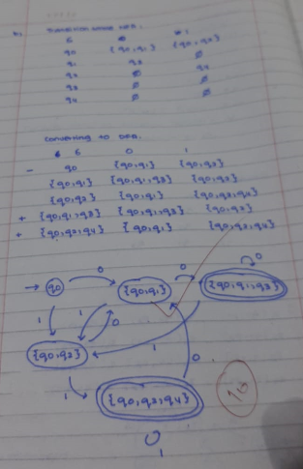

**c) Provide the Deterministic Finite Automata and transition table also mark the initial and final states for the following real world scenario:**











**We have a house, with one door, 2 push buttons and 3 lights. At the default state the lights are all turned off. In your case consider buttons as p1 and p2, lights as l0 (no lights on), l1, l2 and l3 and you must consider l1 as the entrance light.**

* **When you enter the house, you can press one of the 2 push buttons you have, p1 or p2. When you press any of those buttons, the l1 light turns on.**
* **Now you have entered the house and you want to move to the house rooms. (Kitchen or bedroom).**
* **If you press the button p1, l1 turns off and l2 turns on. Instead if you press the button p2, l1 turns off and l3 turns on.**
* **Pressing another time any of the 2 buttons, p1 or p2, the light that is currently on will turn off, and we’ll get back at the initial state of the system.**
* **In your case you may consider l0, l1, l2 and l3 as states, p1 and p2 as the alphabet.**

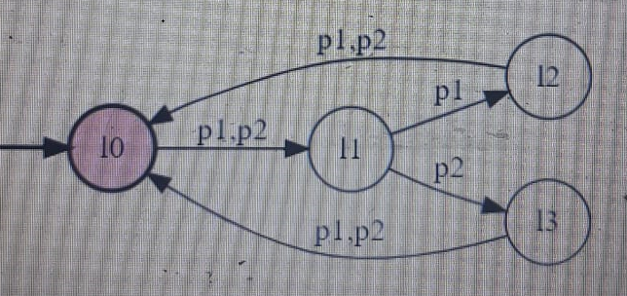3) Consider the following NFA- λ, construct an equivalent DFA. Show all steps [10 points]



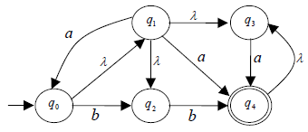

Note: λ represents the *empty string*.

Question 3: Draw FA of the following REs: [10]

A. (0+1)*00

B. a (ab)* aa

C. a+b + a(a+b)* a + b(a+b)*b

D. (0+1)*111(0+1)*

**Question 2: Regular exp. (R.E.) & FA’s (5+5+5+5+5) Points**

1. **Construct the FA for a language upon ∑ ={a,b,c} which accepts all strings not ending with "abc".**
2. **Construct the DFA A for strings accepting all 0's and odd 1's. State the R.E.**
3. **Construct the DFA B for strings accepting all 1's ending with odd 0's.State the R.E.**
4. Consider the language L which recognize the string w defined over ∑ = {a,b,0,1 }, if w belong to language then it must satisfies the following conditions:
5. |w|<=2
6. String must start with either a or b.
7. String can end with any of the alphabets.

Find Regular Expression and draw DFA of the above given language?

1. Design NFA’s to recognize the following set of strings
2. abc, abd, aacd. Assume the alphabet is {a,b,c,d}.
3. 0101, 101, and 011.

**Question 1: (5+5) Points**

**A vending machine is an automated selling machine. Give a DFA and the transition table for this machine that sells a number of items (chips, candies, etc.) for 4 rupees each. It accepts only 1 and 2 rupees, and refunds all money if more than 4 rupees is added. Multiple items can be purchased in one go. The accepted strings are the language defined by this vending machine automaton. Following are the some of the accepted and rejected strings for this language:**

**- Ɛ (reject)**

**- 22 (accept)**

**- 1222 (reject)**

**- 1222221111 (accept)**

**[Hint: There is only one accepting state.  Refund amount returns you to the start state in DFA and the amount becomes ZERO up to that letter (rupees) in any given input string.]**

**Question 2: (DFA) (4+2+4) Points**

1. **Find the DFA for the language L of string which does not contain the substring bb and ends with 'a' defined over alphabet {a, b}.**
2. **Construct the FA for the following regular expression.** **1*(0*01*) *+1+0+λ**
3. **Find the DFA corresponding to set of strings with either no 1 preceding a 0 or no 0 preceding a 1.**

**Question 4: (Conversion epsilon-NFA to DFA) 10 Points**

**Construct the DFA from the Epsilon NFA given in figure 1.**

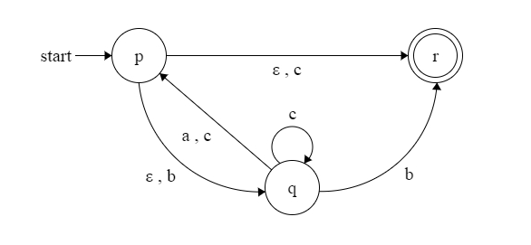

**Figure 1**

**Note: Show steps of your method properly to get full credit.**

**b) Convert the following NFA to equivalent DFA.**

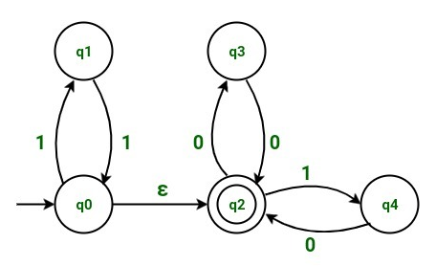

**a.** Design the DFA for Regular Expression ( lambda + b )(ab)∗(lambda + a). Defined over alphabet Σ={a,b},also define language.

**b.** Design the DFA for Regular Expression ab(ab)* ba(ba)* or ba(ba)* ab(ab)*. Defined over alphabet Σ = {a, b}, also define language.

**3: Non- Deterministic Finite Automata (3+3) Points**

**a.** Design the NFA for all the strings with even number of 0’S followed by an odd number of 1’s. Defined over alphabet Σ = {0,1}.

**b.** Design the NFA for the set of all strings in which both the number of a’s and the number of b’s are even. Defined over alphabet Σ = {0,1}.

**b.**Convert the following E − NFA to DFA.

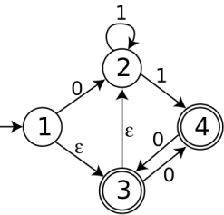

**Question 2: Deterministic Finite Automata (3+3) Points Marks Distribution**

1 if wrong attempt

2 if little mistake

3 if correct

**a.** Design the DFA for Regular Expression 0 + 1 + lambda + 00∗1∗(0 + 1)∗. Defined over alphabet Σ{0,1}.

**b.** 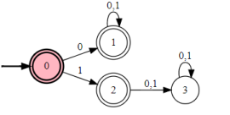

**c.** Design the DFA for Regular Expression (00)* (11)*1. Defined over alphabet Σ{0,1}.

**2 OF 3**

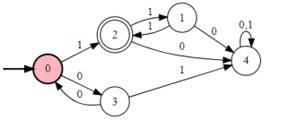

**Question 5: Non- Deterministic Finite Automata (5+10) Points a.** Convert the following e− NFA to DFA

**Marks Distribution**

1 if wrong.

3 If no DFA and no initial and final states

4 if No DFA

4 if no proper final states and initial state

5 if correct

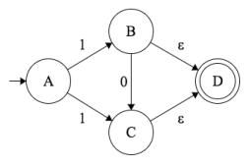**5 OF 3**

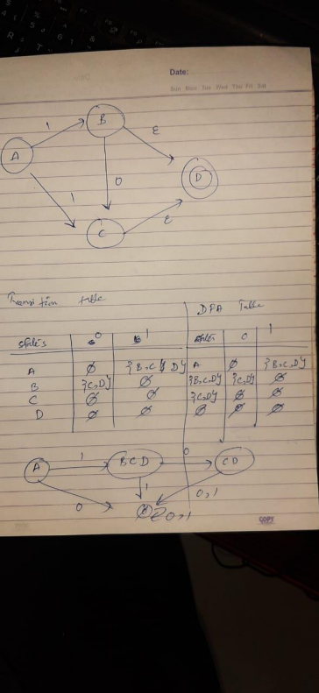**6 OF 3**

**b.** Draw the Non-Deterministic Finite Automata based on the following Scenario. **Marks Distribution**

2 if states not equal to 5, even if student has drawn NFA

5 states 2

Final state 1

Initial 1

Transitions if complete 6 else 3.

**Enemy AI**

Finite State Machines allows us to map the flow of actions in a game's computer-controlled players. Let's say we were making an action game where guards patrol an area of the map. We can have a Finite State Machine with the following properties:

**States:** For our simplistic shooter we can have: Patrol **(P)**, Attack **(A)**, Reload **(R)**, Take Cover **(TC)**, and Deceased **(D)**.

**Initial State:** As it's a guard, the initial state would be Patrol.

**Accepting States:** An enemy bot can no longer accept input when it's dead, so our Deceased state will be our accepting one.

**Alphabet:** For simplicity, we can use string constants to represent a world state: Player approaches **(PA)**, Player runs **(PR)**, Full health **(FH)**, Low health **(LH)**, No health **(NH)**, Full ammo **(FA)**, and Low ammo **(LA)**.

**Transitions:** As this model is a bit more complex than traffic lights, we can separate the transitions by examining one state at a time:

**Patrol**

If player approaches go to the Attack state.

If we run out of health, go to the Deceased state.

**Attack**

If ammo is low, go to the Reload state.

If ammo is low, go to the Diseased.

If health is low, go to the Take Cover state.

If the player escapes (runs), go to the Patrol state.

If we run out of health, go to the Deceased state.

**Reload**

If ammo is full, go to the Attack state.

**7 OF 3**

If health is low, go to the Take Cover state.

If we run out of health, go to the Deceased state.

**Take Cover**

If health is full, go to the Attack state.

If health is full, go to the Reload state.

If ammo is low, go to the Reload state.

If we run out of health, go to the Deceased state.

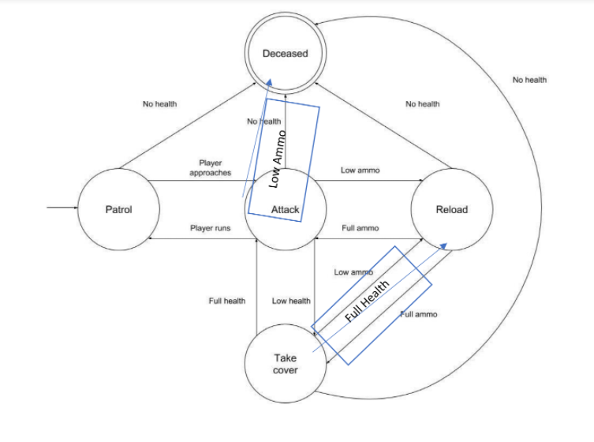**Question # 4 (5+5 Points)**

Design the FA for following languages

$L=\{aa, bb, aaaa, bbbb, λ\}$

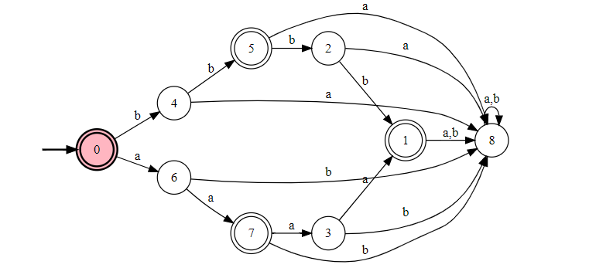

$L=\{vwz:\left|w\right|=1, vϵ{\left\{aa\right\}}^{+}, z ϵ{\left\{bb\right\}}^{*}, wϵ{\left\{a,b\right\}}^{*} \}$

${\left(aa\right)}^{+}(a+b){\left(bb\right)}^{*}$

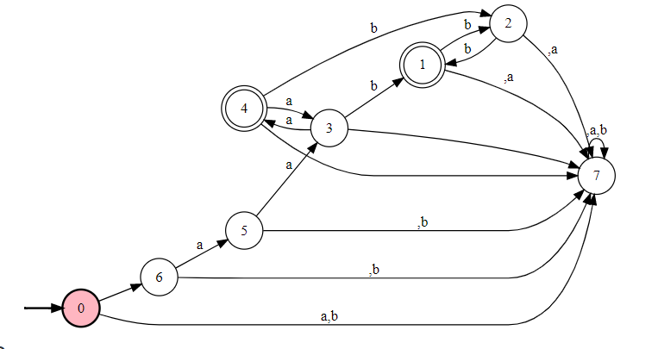

**Question # 5 (5 Points)**

Convert the following NFA to DFA

This is DFA already as I said every DFA is single ton NFA.

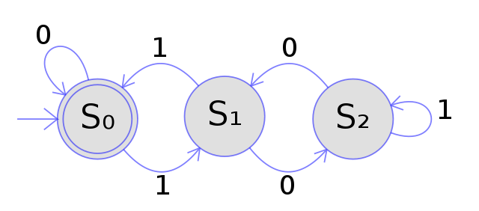

**Question # 4 (5+5 Points)**

Design the FA for following languages

$L=\{bbbb, a, λ, ba, baa\}$

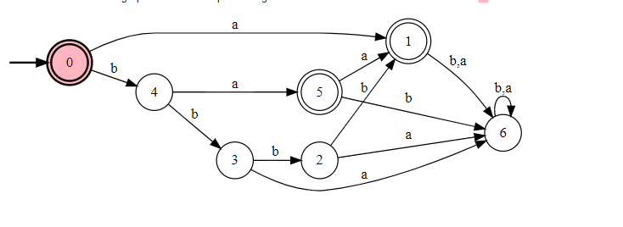

$L=\{zwv:\left|w\right|=2, wϵ{\left\{a,b\right\}}^{+}, z ϵ{\left\{a,b\right\}}^{+}, vϵ{\left\{aba\right\}}^{+} \}$

${\left(a+b\right)}^{+}\left(a+b\right){\left(a+b\right)}^{+}{\left(aba\right)}^{+}$

OR

$\left(a+b\right)\left(a+b\right){\left(a+b\right)}^{+}{\left(aba\right)}^{+}$

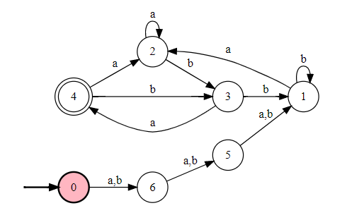

**Question # 5 (5 Points)**

Convert the following NFA to DFA

In a precise way send 0 from q2 to dead state

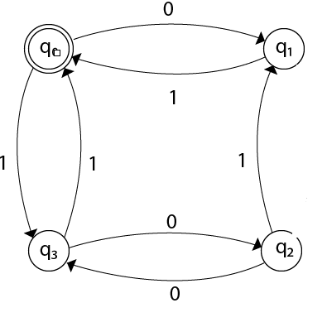

**Question # 4 (5+5 Points)**

Design the FA for following languages

$L=\{aaa, bab, aba, bbbb, λ\}$

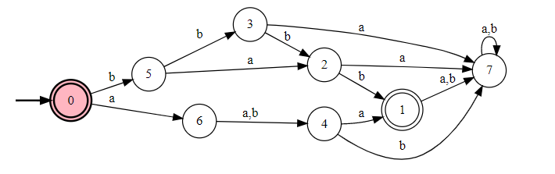

$L=\{vwz:\left|w\right|=1, vϵ{\left\{ab\right\}}^{+}, z ϵ{\left\{ba\right\}}^{*}, wϵ{\left\{a,b\right\}}^{*}\}$

${\left(ab\right)}^{+}\left(a+b\right){\left(ba\right)}^{*}$

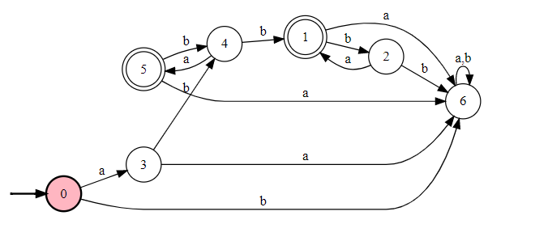

**Question # 5 (5 Points)**

Convert the following NFA to DFA

Draw outgoing transition of final state to a newly introduced dead state.

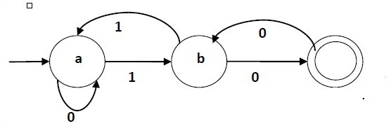

**Question # 4 (5+5 Points)**

Design the FA for following languages

$L=\{aba, baba, aab,λ\}$

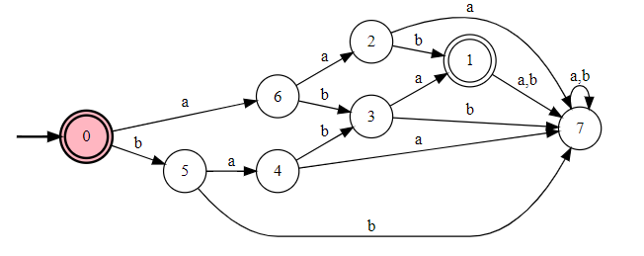

$L=\{vwz:\left|w\right|=1, vϵ{\left\{aba\right\}}^{+}, z ϵ{\left\{aba\right\}}^{*}, wϵ{\left\{a,b\right\}}^{*}\}$

${\left(aba\right)}^{+}(a+b){\left(aba\right)}^{*}$



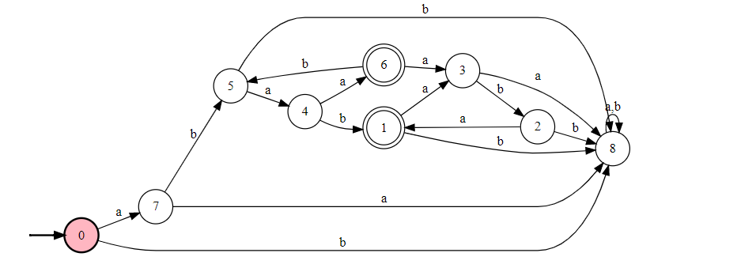

**Question # 5 (5 Points)**

Convert the following NFA to DFA.

This is dfa already

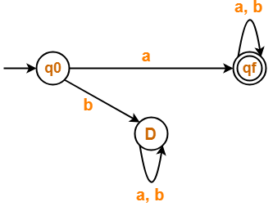

**Question # 4 (5+5 Points)**

Design the FA for following languages

$L=\{aaa, bbb, aa, bbbb, λ\}$

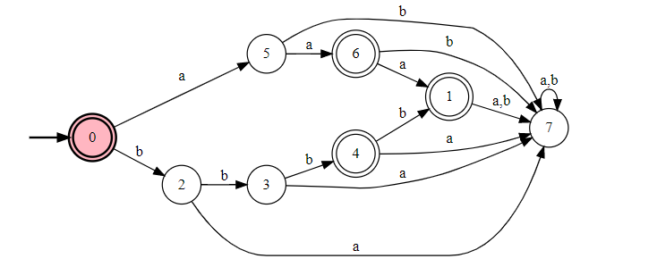

$L=\{vwz:\left|w\right|=1, vϵ{\left\{aaa\right\}}^{+}, z ϵ{\left\{bba\right\}}^{*}, wϵ{\left\{a,b\right\}}^{*}\}$

${\left(aaa\right)}^{+}\left(a+b\right){\left(bba\right)}^{*}$

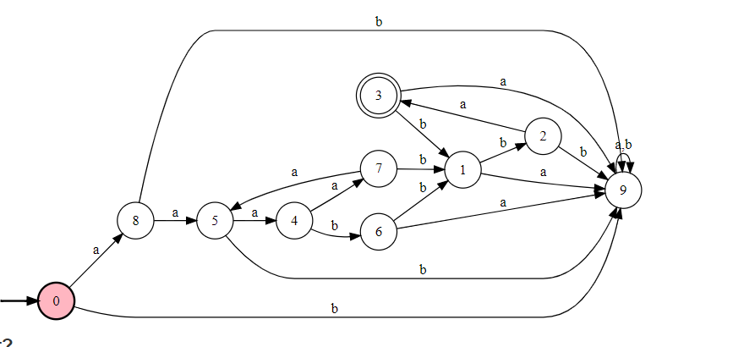

**Question # 5 (5 Points)**

Convert the following NFA to DFA.

Send the missing transition to the dead state it would become DFA

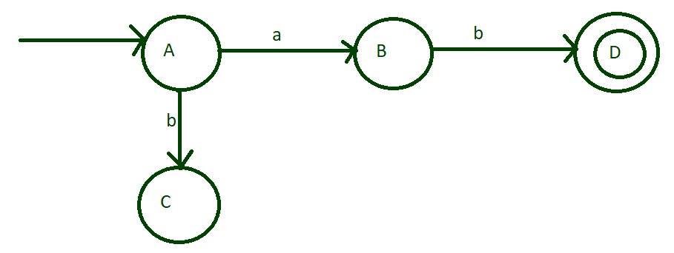

**Question # 4 (5+5 Points)**

Design the FA for following languages

$L=\{abb, baa, λ, bba, bba\}$

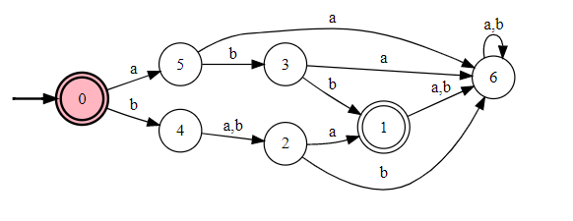

$L=\{vwz:\left|w\right|=3, vϵ{\left\{a,b\right\}}^{+}, z ϵ{\left\{a,b\right\}}^{*}, wϵ{\left\{a,b\right\}}^{+}\}$

${\left(a+b\right)}^{+}\left(a+b\right)\left(a+b\right){\left(a+b\right)\left(a+b\right)}^{*}$

Or

$(a+b)\left(a+b\right)\left(a+b\right)(a+b){\left(a+b\right)}^{*}$

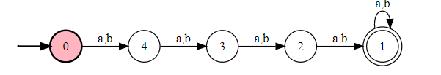

**Question # 5 (5 Points)**

Convert the following NFA to DFA.

Send the missing outgoing transitions to dead state the NFA would be converted to DFA

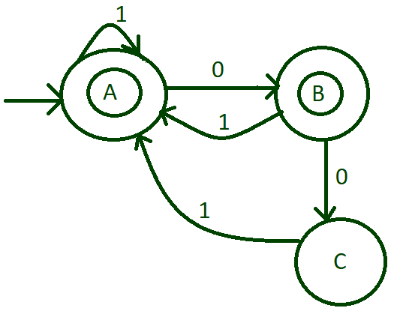

**Question # 4 (5+5 Points)**

Design the FA for following languages

$L=\{bbb, aaa, λ, b, bb\}$

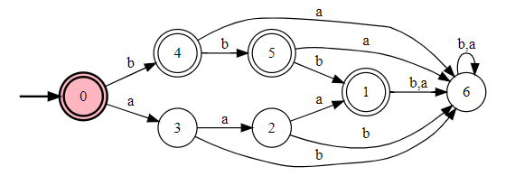

$L=\{zwv:\left|w\right|=1, vϵ{\left\{a,b\right\}}^{+}, z ϵ{\left\{a,b\right\}}^{*}, wϵ{\left\{a,b\right\}}^{+}\}$

$(a+b)\left(a+b\right){\left(a+b\right)}^{+}$

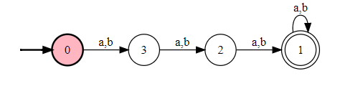

**Question # 5 (5 Points)**

Convert the following NFA to DFA.

If alphabet is $Σ=\left\{a\right\}then this is DFA already, if you take alphabet Σ\left\{a,b\right\}then send b from every state to dead state it$

It would converted to DFA

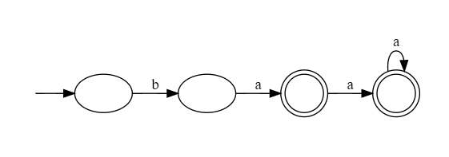

**Question # 4 (5+5 Points)**

Design the FA for following languages

$L=\{a, ba, λ, bbba\}$

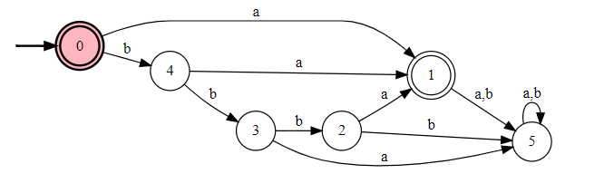

$L=\{vwz:\left|w\right|=2, vϵ{\left\{a,b\right\}}^{*}, z ϵ{\left\{a,b\right\}}^{+}, wϵ{\left\{a,b\right\}}^{+}\}$

$\left(a+b\right)\left(a+b\right){\left(a+b\right)(a+b)}^{*}$

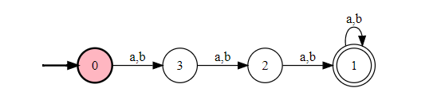

**Question # 5 (5 Points)**

Convert the following NFA to DFA.

If alphabet is Σ={a}then this is DFA already,if you take alphabet Σ{a,b}then send b from every state to dead state it

It would converted to DFA

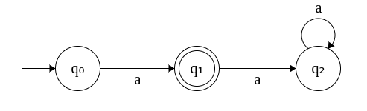

**Question # 4 (5+5 Points)**

Design the FA for following languages

$L=\{aba, bab, bbbb,aaa\}$

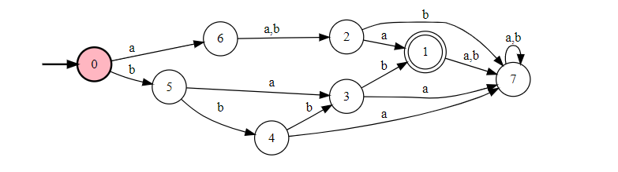

$L=\{vwz:\left|v\right|=4, vϵ{\left\{a,b\right\}}^{*}, z ϵ{\left\{a,b\right\}}^{+} , wϵ{\left\{a,b\right\}}^{*}\}$

${\left(a+b\right)\left(a+b\right)\left(a+b\right)(a+b)\left(a+b\right)}^{+}$

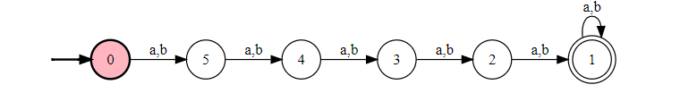

**Question # 5 (5 Points)**

Convert the following NFA to DFA.

Draw the outgoing transition of **b** from c to dead state. This would become DFA

.

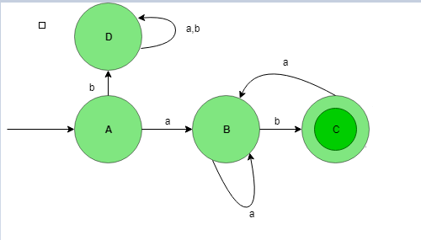

# Regular Expression:

**1) Give the equivalent REs for the following regular expressions other than the given one.**

**1. (b + bb)* a (b + bb)\***

**2. (bb)(bb)* a*(bb) + (bb)+ a* (bb)*(bb)**

**Solution:**

**1) b*ab\***

**2)(bb)+a*(bb)\***

Question 2: Write REs of the following: [10]

A. Set of all string having substring 00

B. The language of all strings over the alphabet { a, b } that contain exactly two a's.   
C. Set of all string end with 01

D. The language, defined over G ={a, b}, of words starting with double a and ending in double b

E. Strings not containing the substring 110.

Question 4: Write the language that is accepted by each of the following: [10]

| A. | B. |
| --- | --- |

1. **Construct the DFA A for strings accepting all 0's and odd 1's. State the R.E.**
2. **Construct the DFA B for strings accepting all 1's ending with odd 0's.State the R.E.**
3. Consider the language L which recognize the string w defined over ∑ = {a,b,0,1 }, if w belong to language then it must satisfies the following conditions:
4. |w|<=2
5. String must start with either a or b.
6. String can end with any of the alphabets.

Find Regular Expression and draw DFA of the above given language?

Consider the following expressions:

1. ((a ∪ b) ∪ (ab))*
2. ($a^{+}a^{n}b^{n}$)
3. ((ab)* ∅)
4. (((ab) ∪ c)*∩(b ∪ c*))
5. (∅* ∪ (bb*))

(ii) Which of the above is not a regular expression. Give precise reasoning. And for each of the above that is a regular expression, give a simplified equivalent regular expression.

(iii) For each of the above that is a regular expression, give descriptive definition of that language.

Question3: Derive the RE for the language accepted the following nfa. For full credit show all the steps clearly.

[Hint: Use approach discussed in Kleen's Theorem] [15 points]



**Question 3: (Regular Expressions) (10) Points**

**Express each of these languages over Σ = {0, 1} using a regular expression.**

**a) L1 the set consisting of the strings 0, 11, and 010**

**b) L2 the set of strings of three 0s followed by two or more 0s, containing no 1s**

**c) L3 the set of strings of odd length**

**d) L4 the set of strings that contain exactly one 1**

**e) L5 the set of strings ending in 1 and not containing 000**

**f) the set of strings containing a string of 1s such that the number of 1s equals 2 modulo 3, followed by an even number of 0s**

**Question 5: (GTG and State Elimination) 10 Points**

**Find the regular expression of the DFA given in figure 2, using state elimination method.**



**Figure 2**

**Note: Show steps of your method properly to get full credit.**

**17. Regular expression for all strings starts with ab and ends with bba is.**

a) aba*b*bba

b) ab(ab)*bba

c) ab(a+b) *bba

d) All of the mentioned

**19. Which of the following does the given NFA represent?**

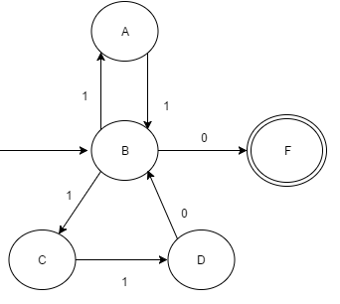

a) {11, 101} * {01}

b) {110, 01} * {11}

c) {11, 110} * {0}

d) {00, 110} * {1}

**Question 2: (Regular Languages) (8+8+2+2 Points)**

1. **Perform the union of the following DFAs.**
2. **Perform Concatenation of following DFAs.**
3. **Identify the languages of the following DFAs.**
4. **Write down the regular Expressions of the following DFAs.**

| DFA Solved Examples | How to Construct DFA | Gate Vidyalay | DFA Solved Examples | How to Construct DFA | Gate Vidyalay |
| --- | --- |
|  |  |

**Question 2: (Regular Languages) (8+8+2+2 Points)**

1. **Perform the union of the following DFAs.**
2. **Perform Concatenation of following DFAs.**
3. **Identify the languages of the following DFAs.**
4. **Write down the regular Expressions of the following DFAs.**

| What is the difference between following two finite automata? - Computer  Science Stack Exchange | finite state machine tutorial point online - |
| --- | --- |
|  |  |

**a.** The set of all string over Ʃ = {0, 1}, having at most one pair of 0’s or at most one pair of 1’s. Some of the strings in the given language are: {00, 11, 00111, 00011, 0011, ....}

**b.** Find a regular expression for the language L= {w| w ϵ{0,1}* }: w has no pair of consecutive one’s. Defined over alphabet Σ = {0,1}

**c.** Find a regular expression for the given DFAs.

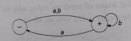 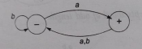 **DFA1 DFA2**

**Question 4: Generalized Transition Graph and NFA to DFA. (10+5) Points a.** Find the regular expression of given GTG using state elimination method.

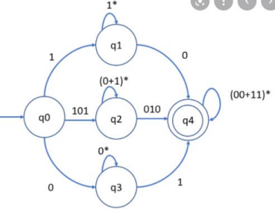

**Question 3: Regular Expressions (3+3) Points Marks Distribution**

1 if wrong attempt

2 if little mistake

3 if correct

**a.** The language of the words which does not have 0,1 as the third last letter. Defined over alphabet Σ = {0,1}.

(0 + 1 + lambda )(0 + 1 + lambda)

Or (0 + 1)(0 + 1) + 1 + 0 + lambda

or(0 + 1 + lambda)(0 + 1) + lambda

00

**b.** The set of strings of even length strings but ends with aa. Defined over alphabet Σ{a,b}. ((a + b)(a + b))∗aa

**Question 4: Generalized Transition Graph (5 Points) Find the regular expression of given ϵ-NFA using state elimination method. Marks Distribution**

1 if something irrelevant

3 if eliminates state q2

5 if correct

**3 OF 3**

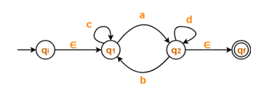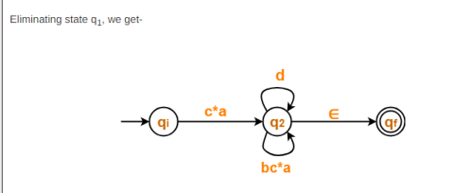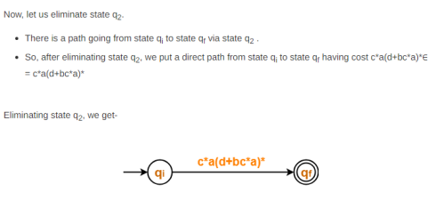

**Question # 3 (5+5 Points)**

Write down the RE for following languages.

1. {$awaa:w≥3,wϵ{\{b\{a,b\}}^{*}bb\}\}$
$ab{\left(a+b\right)}^{*}bbaa$

2. Language of the words that **start and end with different double letters** and have **bab** as a substring.

$aa{\left(a+b\right)}^{*}bab{\left(a+b\right)}^{*}bb+bb{\left(a+b\right)}^{*}bab{\left(a+b\right)}^{*}aa+bbab{\left(a+b\right)}^{*}aa$

**Question # 3 (5+5 Points)**

Write down the RE for following languages.

1. {$aawab:\left|w\right|≥4,wϵ{\{ba\{a,b\}}^{*}ba\}\}$
$aaba{\left(a+b\right)}^{*}ba$

2. Language of the words that **start with aa and end bb** and have **aab** as a substring.

$aabb+aaabb+aa{\left(a+b\right)}^{*}aab{\left(a+b\right)}^{*}bb$

If we take aabb the word would be aabb, which has substring aab.

Same for aaab.

**Question # 3 (5+5 Points)**

Write down the RE for following languages.

1. {$abwba:\left|w\right|≤3,wϵ{\{b\{a,b\}}^{*}b\}\}$
$abb(a+b+λ)bba$

2. Language of the words that **start with ba and end with ab** and have **bbb** as a substring.

$ba{\left(a+b\right)}^{*}bbb{\left(a+b\right)}^{*}ab$

**Question # 3 (5+5 Points)**

Write down the RE for following languages.

1. {$abbwbba:\left|w\right|≤3,wϵ{\{a\{a,b\}}^{+}b\}\}$
$abba(a+b+λ)bbba$

2. Language of the words that **start with aaa and end with abbb** and have **bbb** as a substring.

$aaa{\left(a+b\right)}^{*}abbb$

**Question # 3 (5+5 Points)**

Write down the RE for following languages.

Note: w is already >3

1. {$aawaa:\left|w\right|≥3,wϵ{\{aa\{a,b\}}^{*}bb\}\}$
$aaaa{\left(a+b\right)}^{*}bbbb$

2. Language of the words that **start and end with different double letters** and have **aaa** as a substring.

$aa{\left(a+b\right)}^{*}aaa{\left(a+b\right)}^{*}bb+aaabb+aaaabb+ bb{\left(a+b\right)}^{*}aaa{\left(a+b\right)}^{*} aa+bbaaa+bbaaaa$

**Question # 3 (5+5 Points)**

Write down the RE for following languages.

1. {$awa:\left|w\right|≤2,wϵ{\{a\{a,b\}}^{*}b\}\}$

$aa{\left(a+b\right)}^{*}ba$

1. Language of the words that **start and end with same double letters** and have **abb** as a substring.

$aabbaa+aa{\left(a+b\right)}^{*}abb{\left(a+b\right)}^{*}aa+bb{\left(a+b\right)}^{*}abb{\left(a+b\right)}^{*}bb$

**Question # 3 (5+5 Points)**

Write down the RE for following languages.

1. {$awa:\left|w\right|≤4,wϵ{\{b\{a,b\}}^{*}b\}\}$
$ab(a+b+λ)ba$

2. Language of the words that **start with ab and end aa** and have **baa** as a substring.

$abaa+abaaa+ab{\left(a+b\right)}^{*}baa{\left(a+b\right)}^{*}aa$

**Question # 3 (5+5 Points)**

Write down the RE for following languages.

1. {$awb:\left|w\right|≤3,wϵ{\{a\{a,b\}}^{*}a\}\}$
$aa(a+b+λ)ab$

2. Language of the words that **start and end with different double letters** and have **aba** as a substring.

$aababb+aa{\left(a+b\right)}^{*}aba{\left(a+b\right)}^{*}bb+ bb{\left(a+b\right)}^{*} aba{\left(a+b\right)}^{*} aa$

**Question # 3 (5+5 Points)**

Write down the RE for following languages.

1. {$awb:\left|w\right|≤4,wϵ{\{bb\{a,b\}}^{*}b\}\}$
$abb{\left(a+b\right)}^{*}bb$

2. Language of the words that **start with bb and end aa with**  and have **baa** as a substring.

$bbaa+bbaaa+ bb{\left(a+b\right)}^{*}baa{\left(a+b\right)}^{*}aa$

# Regular Expression Properties:

**1) Let L4 = L1 U L2 . If L1 is regular and L2 is not regular, then L4 is regular. Discuss with an example.**

Solution:

an bn and (a+b)* unite to form (a+b)* which is regular language

**True/False:**

1. There is a regular language L for which there is exactly one regular expression R with L(R) = L.

2. Intersection of two non-regular languages is always non-regular.

3. Given a non-regular language L1, {L1 U (L1)R} – where (L1)R is the reversal of L1, will always be a regular

language.

4. The complement of a non-regular language must be non-regular.

5. Let L4 = L1L2L3. If L1 and L2 are regular and L3 is not regular, it is possible that L4 is regular.

6. Every subset of a regular language is regular.

7. If, two strings x and y, defined over Σ, are run over an FA accepting the language L, then x and y are said to belong to the same class if they end in the same state, no matter that state is final or not.

8. Let FA3 be an FA corresponding to FA1+FA2, then the initial state of FA3 must correspond to the initial state of FA1 or FA2

9. If L1 and L2 are expressed by regular expressions r1 and  r2, respectively then the language expressed by  r1 + r2 will be regular.

| 1) (a* + b*)* = (a + b)* this expression is __________   1. True 2. False | 6) What do automata mean?   1. Something done manually 2. Something done automatically |
| --- | --- |
| 2) Alphabet S = {a, Bc, cC} has ____ number of letters   1. 1 2. 2 3. 3 | 7) If S = { x }, then S* will be   1. {x,xx,xxx,xxxx,…} 2. {^ ,x,xx,xxx,xxxx,…} |
| 3) If S = {aa, bb}, then S* will not contain   1. aabbaa 2. bbaabbbb 3. aaabbb 4. aabbaaaa | 8) language can be expressed by more than one FA”. This statement is ______   1. True 2. False 3. Sometimes true & sometimes false 4. None of these |
| 4) (a+λ)*b + λ is equivalent to:   1. (a+b)a*b 2. (a+b)a*b + λ 3. (a+b) a*ab + λ 4. none of these | 9) (aa+bb*)* is equivalent to:   1. (aa+ab)* 2. (b*aaab*)* 3. (aa+a+b)* 4. None of these |
| 5) (b+ab)* (a + λ) is equivalent to:   1. b*(abb*)* + b*(abb*)*a 2. b*(ab*)* (a+ λ) 3. b*(abb*)* 4. none of these | 10) In an FA, when there is no path starting from initial state and ending in final state then that FA   1. accept null string 2. accept all strings 3. accept all non empty strings 4. does not accept any string |

| 3) Two FAs are equivalent if they have same no. of states. | T/F |
| --- | --- |

**Q2) Provide short answers to each of the following questions:** **[10 points = 5*2 points]**

a) Every subset of a regular language is regular.

b) Let L4 = L1L2L3. If L1 and L2 are regular and L3 is not regular, it is possible that L4 is regular.

e) Let L4 = L1L2L3. If L1 and L2 are regular and L3 is not regular, it is possible that L4 is regular.

**Question 1: True** or **False (With Reasons) (5) Points**

1. **There is a regular language L for which there is exactly one regular expression R with L(R) = L.**
2. **Union of regular language with context free language is not always a regular language.**

| 1) (a* + b*)* = (a + b)* this expression is __________   1. True 2. False | 2) (L1 ∪ L2)* = L1* ∪ L2*   1. True 2. False |
| --- | --- |
| 3) (ab)*a = a(ba)*   1. True   False | 4) L1* = L1+ ∪∅   1. True 2. False |
| 5) (L1 ∪ L2)* = (L2 ∪ L1)*   1. True 2. False | 6) (a ∪ b)* b (a ∪ b)* = a* b (a ∪ b)*   1. True 2. False |
| 7) [(a ∪ b)* b a (a ∪ b)* ∪ a*b*] = (a ∪ b)*   1. True 2. False | 8) (L1L2)* = L1*L2*   1. True 2. False |
| 9) [(a ∪ b)* b (a ∪ b)* ∪ (a ∪ b)* a (a ∪ b)*] =   1. True 2. False | 10) a+ = a. a*   1. True 2. False |
| 11) If S = { x }, then S* will be   1. {x,xx,xxx,xxxx,…} 2. {^ ,x,xx,xxx,xxxx,…} | 12) If S = {aa, bb}, then S* will not contain   1. aabbaa 2. bbaabbbb 3. aaabbb 4. aabbaaaa |
| 13) Language can be expressed by more than one FA's. This statement is ______   1. True 2. False 3. Sometimes true & sometimes false 4. None of these | 14) (b+ab)*(a+λ)is equivalent to   1. b*(abb*)*+b*(abb*)*a 2. b*(ab*)*(a+λ) 3. b*(abb*)* 4. None of these |
| 15) (aa+bb*)* is equivalent to:   1. (aa+ab)* 2. (b*aaab*)* 3. (aa+a+b)* 4. None of these | 16) (a+b+c)*a(a+b+c)*b(a+b+c)*c(a+b+c)*is equivalent to   1. (b+c)* a(a+c)* b(a+b)* c(a+b+c)* 2. (a+b+c)* a(b+c)* b(a+c)* c(a+b+c)* 3. (b+c)* abc(a+b+c)* 4. None of these |
| 17) In an FA, when there is no path starting from initial state and ending in final state then that FA   1. accept null string 2. accept all strings 3. accept all non-empty strings 4. does not accept any string | 18) (aa+bb)*is equivalent to   1. (aa+ab)* 2. (aa)*+(bb)* 3. (aa+b)* 4. None of these |
| 19) (a+b)*(a+λ)*b+λ is equivalent to   1. (a+b)a*b 2. (a+b)a*b+λ 3. (a+b)a*ab+ λ 4. None of these | 20) What does automata means   1. Performs operation manually 2. Performs operation automatically |

Question 1a: Provide 2-3 line replies to all of the following short questions. Answer that exceeds 3 lines will not be considered. [10 points]

A) If a language can be expressed in the form of FA than why it is needed to use NFA ?

B) Write down differences between Palindrome and Reverse function? Elaborate with example.

C) what are the conditions of NFA-Null to NFA conversion to recognize the language L.

**20. If L is a regular language, complement and reverse of language both will be:**

a) Accepted by NFA

b) Rejected by NFA

c) One of them will be accepted

Question 1: Languages and Alphabets (2+2+2+2 ) Points

Consider the following alphabets and list of the words and answer below mentioned

questions:

Σ={Aa,D,Bc,Cd}

Marks Distribution

0.75 if 1 is correct

1.5 if 2 are correct

2 if are correct

(i) AaBcCd

(ii) AaDBcCd

(iii) AaDAa

a. Check the validity of mentioned alphabet based on the listed words.

All are valid based on alphabet, it has no same prefixes.

b. Take the reverse the of mentioned words.

CdBcAa

CdBcDAa

AaDAa.

c. Give the cardinality of each word.

2 OF 3

AaBcCd →3

AaDBcCd →4

AaDAa→3

d. Let the alphabet be Σ = { a, b, c} and we suppose that language L1 of words in (a^n b^n + c^n)

List the words in L1which would be included in L^2

and L^3.

Marks Distribution

2 if correct, 0.5 if wrong

L^2 = a^n b^n a^n b^n + a^nb^nc^n + c^na^nb^n + c^nc^n

L^3 = (a^nb^na^nb^n + a^nb^nc^n + c^na^nb^n + c^nc^n)(a^nb^n + c^n)=a^nb^na^nb^na^nb^n + a^nb^nc^na^nb^n + c^na^nb^na^nb^n + c^nc^na^nb^n + a^nb^na^nb^nc^n + a^nb^nc^nc^n +c^na^nb^nc^n + c^nc^nc^n

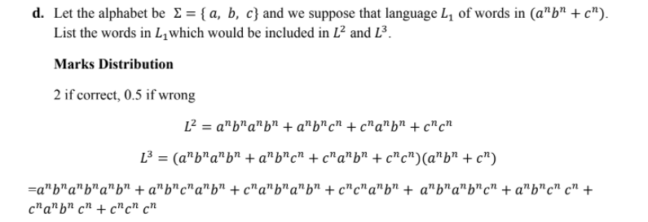

**Question # 1 (5 Points)**

$Prove or Diprove the following alphabet$

$Σ=\left\{CaC, C, Cb, CC\right\}is valid by any example string of your choice$

**CaC: If you make tokens of this word it would create ambiguity**

**Alphabets cant not have same prefixes.**

**Question # 2 (5 Points)**

Let’s assume that we have a languages; ${ca}^{*}b^{*} and {c^{+}a}^{+}b^{+}$ what would be union of these languages.

$c^{+}a^{*}b^{*}$

**Question # 1 (5 Points)**

$Prove or Diprove the following alphabet$

$Σ=\left\{D, F, Daa, DB\right\}is valid by any example string of your choice$

DaaD , when we tokenize this word, we would go in ambiguity so the alphabet is ambigious.

**Question # 2 (5 Points)**

Let’s assume that we have a language $a^{*}b^{*}\left(cc\right)anda^{+}b^{+}({cc}^{*}$**)** what would be union of these languages.

$a^{*}b^{*}(cc^{*})$

**Question # 1 (5 Points)**

$Prove or Diprove the following alphabet$

$Σ=\left\{Da, bb, aa, CC\right\}is valid by any example string of your choice$

**This is a valid alphabet there are no same prefixess**

**Question # 2 (5 Points)**

Let’s assume that we have a language ${\left(aa\right)}^{+}{\left(bb\right)}^{*} and {\left(aa\right)}^{*}{\left(bb\right)}^{+}$ what would be union of these languages.

${\left(aa\right)}^{*}{\left(bb\right)}^{*}$

**Question # 1 (5 Points)**

$Prove or Diprove the following alphabet$

$Σ=\left\{C, Ca, Cb, aaa\right\}is valid by any example string of your choice$

**CCa, in this lexical analyser would get confused so this is not valid alphabet.**

**Question # 2 (5 Points)**

Let’s assume that we have a language ${\left(aaa\right)}^{+}{\left(bab\right)}^{*} and {\left(aaa\right)}^{*}{\left(bab\right)}^{+}$ what would be union of these languages.

${\left(aaa\right)}^{*}{\left(bab\right)}^{*}$

**Question # 1 (5 Points)**

$Prove or Diprove the following alphabet$

$Σ=\left\{B, Bcc, BC, ab\right\}is valid by any example string of your choice$

BccB would create ambiguity for lexical analysser

**Question # 2 (5 Points)**

Let’s assume that we have a language $a^{*}b^{*} and a^{+}b^{+}$ what would be union of these languages.

$a^{*} b^{*}$

**Question # 1 (5 Points)**

$Prove or Diprove the following alphabet$

$Σ=\left\{D, Dbb, BC, abc\right\}is valid by any example string of your choice$

**DDbb would create an ambighuty**

**Question # 2 (5 Points)**

Let’s assume that we have a language $a^{*}b^{*}c and a^{+}b^{+}c^{*}$ what would be union of these languages.

$a^{*}b^{*}c^{*}$

**Question # 1 (5 Points)**

$Prove or Diprove the following alphabet$

$Σ=\left\{A, ABC, BC, ab\right\}is valid by any example string of your choice$

ABCA would create an ambiguity so its invalid

**Question # 2 (5 Points)**

Let’s assume that we have a language $a^{n}b^{n} and a^{n}b^{m}$ what would be union of these languages.

$a^{n}b^{m}$

**Pumping lemma**

**Question 1:**

Apply pumping on language {wwR, w ϵa,b*} to prove that this is not regular language. Also write 2 languages which fall in this category but are regular according you’re thinking.w

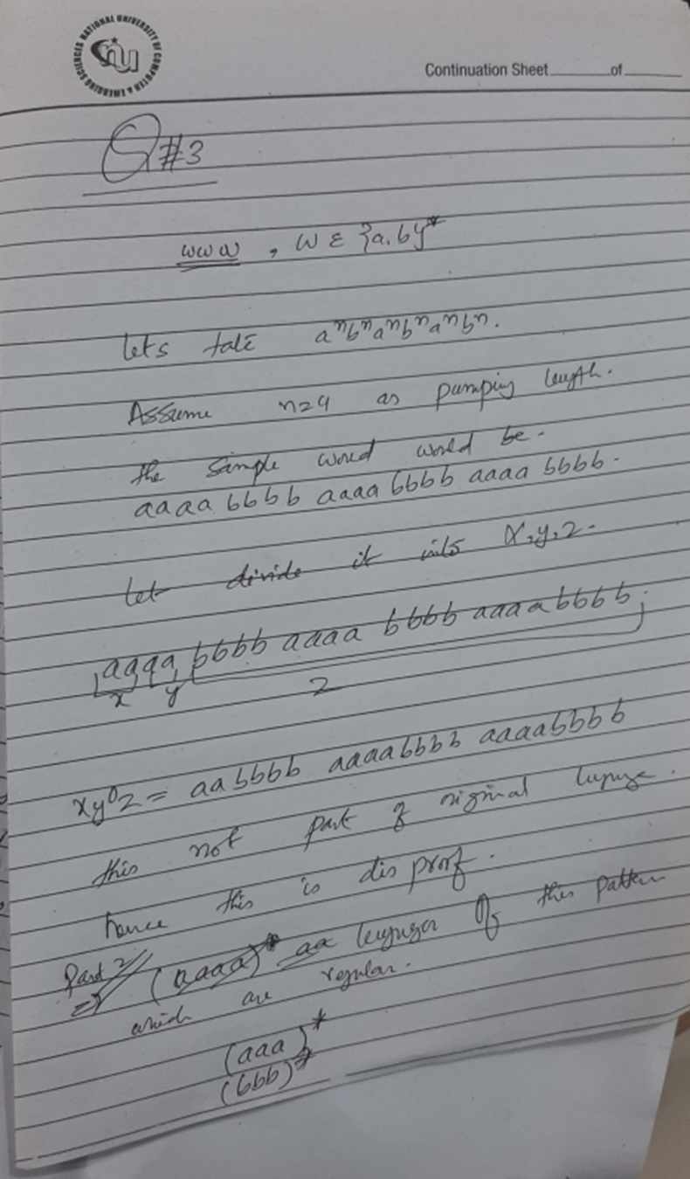

**Question 2:**

Apply pumping on language {ww, w ϵa,b*} to prove that this is not regular language. Also write 2 languages which fall in this category but are regular according you’re thinking.

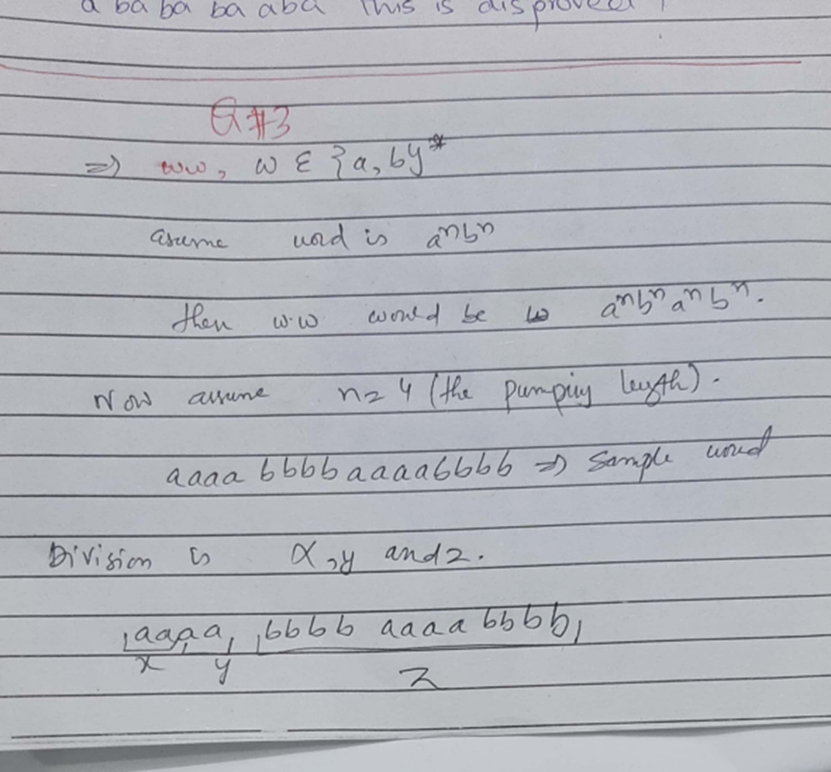

**Question 3:**

Apply pumping on language {wwR, w ϵa,b*} to prove that this is not regular language. Also write 2 languages which fall in this category but are regular according you’re thinking.

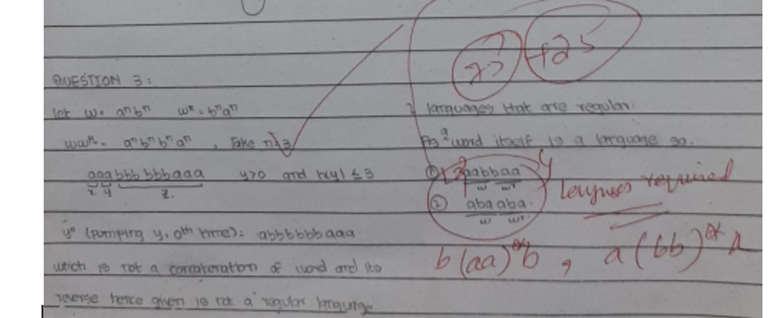

**Question 4:**

Apply Pumping Lemma on languages L1 and L3 to prove that these are not regular languages.

(i) L1 = {a^nb^(n+m)c^m: n, m ≥ 0}

(ii) (ii) L2 = {(ab)^2n: n ≥ 0}

(iii) (iii) L3 = {a^nb^(2n+6): n ≥ 0}

